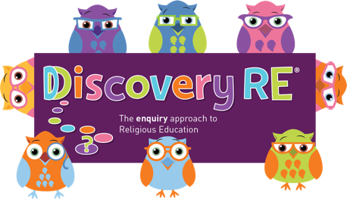
Discovery RE Knowledge Organiser
This knowledge organiser is a guide, offering key information to point the teacher in the right direction as to the beliefs underpinning the particular enquiry.
The summaries must not be taken as the beliefs of ALL members of the particular religion.
Religion /Worldview: Islam | Enquiry Question: Does belief in Akhirah (life after death) help Muslims lead good lives? | Age: 10/11 Year Group: 6 Summer 1 and 2
In this enquiry, the children look at how belief in life after death has different interpretations for Muslims. They will look at the different ways that Muslims live their view of a good life. The enquiry includes some controversial content and it is important that the children get the opportunity to explore this aspect fully.

Core Knowledge (see also background information documents) |  | Link to other aspects of belief | Personal connection / resonance
Part 1  Akhirah - Life after death  Muslims believe that when you die there is a judgment day. Allah, who is perfect justice, will decide on your next step after looking at the evidence collected during your life  Part 2  Jihad is defined as a personal struggle against evil.  Muslims define Jihad in different ways, for some it is an individual daily struggle to do the right thing, to avoid evil and temptation. For some other Muslims jihad can be taken to mean literally fighting against a perceived enemy or evil. This has led some Muslims to take extreme action and even die for their faith as well as kill others in the belief that this action will lead them straight to paradise.  Just War  A Just war is one that might be acceptable to fight  Holy War  A Holy war has religion as the driving force – usually to defend it from attackers |  | - Belief in Allah and his importance  - Zakat – money given to charity as a duty  - Sadaqah – money given to a charity as a choice  - Khums – Shia Muslims give 20% of their money after expenses to charity | - What do I think is important in life?  - What do I struggle with?  - Why is it important to show commitment to things you believe in?  - What issues do you think are important?  - Why do people protest?  - Is every way of protesting acceptable? Explain
Key Terms and definitions | History/Context | Impact on believer/daily life | Spiral curriculum link
Akhirah: life after death  Jihad: Struggle  Lesser Jihad: a struggle or fight against the enemies of Islam  Greater Jihad: personal individual struggle against evil | - The word ‘Jihad’ has different interpretations – the word means struggle and can be interpreted as a daily effort to do the right thing or for some can involve an armed response against what they see as evil  - Cultural and regional situations will play a big aspect on how someone views Jihad | Muslims believe Allah will judge them when they die and their daily thoughts, words and actions will be used as evidence. This will encourage them to live in the ‘right way’ | Builds on previous Islam enquiries.  Refer to previous learning on the Five Pillars (Yr6 Autumn 1) as these will play a big part in leading a good life.  Remind students of how important Allah is to Muslims as it will help them understand Jihad.
Home learning ideas/questions: What issues are important to us? How far would we go to defend our beliefs?

© 2020 Discovery RE Ltd

