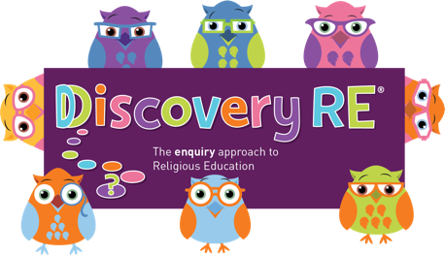
Discovery RE Knowledge Organiser
This knowledge organiser is a guide, offering key information to point the teacher in the right direction as to the beliefs underpinning the particular enquiry.
The summaries must not be taken as the beliefs of ALL members of the particular religion.
Religion /Worldview: Christianity | Enquiry Question: Is Christianity still a strong religion 2000 years after Jesus was on earth? | Age: 10/11 Year Group: 6 Spring 2
This enquiry draws on all previous learning about the concepts of Christianity that have been studied in earlier enquiries and reflects on their meaning and impact in the world today.

Core Knowledge (see also background information documents) |  | Link to other aspects of belief | Personal connection / resonance
Christian concepts such as Lent (the 40 days leading up to Holy Week commemorating Jesus’ time fasting in the desert), Shrove Tuesday (the start of Lent), Ash Wednesday (when ashes from burnt palms from the previous years’ Palm Sunday are placed on believers’ foreheads) are all aspect of Christian preparation for Easter. Advent is the preparation time for Christmas.  Christian charities can demonstrate Jesus’ teaching to love your neighbour (demonstrate Agape)  There are countries where people are persecuted for being Christians and Christians have to suffer if they stand up for their beliefs. |  | Salvation: God sent Jesus to humanity to die and to be resurrected to allow man to have a pathway back to God where he can live with God for eternity. | - What rules would I choose to live by?  - Whose example would I like to emulate in my life? (Can be a variety of people, not just one)  - Could me behaving like that person have a positive impact on my community or the world?
Key Terms and definitions | History/Context | Impact on believer/daily life | Spiral curriculum link
Agape: universal and unconditional love, such as the love for strangers, nature, or God  Harvest: Usually celebrated in September when churches are decorated with fruit and vegetables and Christians given thanks to God for the food and crops.  Fish symbol:  The Greek word for fish is "ichthys." As early as the first century, Christians made an acrostic from this word: Iesous Christos Theou Yios Soter, i.e. Jesus Christ, Son of God, Saviour | Mothering Sunday began in the 16th Century where, on the fourth Sunday of Lent, people would return to their mother church for a special service.  The fish symbol attracted less attention than a cross so was an important method of communication to early persecuted Christians. Current car-sticker and business-card or webpage uses of the fish hark back to this practice, allowing others to see that the person using it is a Christian. | A Christian today may use the fish symbol in work or in full view of others (e.g. car stickers) to show their commitment to their faith in public.  Christians would give to charity (although this is not a requirement or obligation) to demonstrate love for their neighbour and emulate Jesus’ example and commandment. | Final Christianity unit (unless optional Yr 6 unit is studied later). This enquiry draws all previous learning together.
Home learning ideas/questions: Do we have any rules or values that we live to that have existed for a long time? What values do we try to follow in our lives? Do we think these values will still be important in e.g. 2000 years?
© 2020 Discovery RE Ltd

