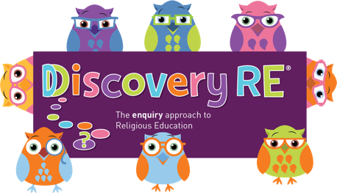
Discovery RE Knowledge Organiser
This knowledge organiser is a guide, offering key information to point the teacher in the right direction as to the beliefs underpinning the particular enquiry.
The summaries must not be taken as the beliefs of ALL members of the particular religion.
Religion /Worldview: Christianity | Enquiry Question: What is the best way for a Christian to show commitment to God? | Age: 9/10 Year Group: 5 Summer 2
This enquiry looks at ways in which Christians are committed to their faith by evaluating some key areas already studied plus the 10 commandments and Jesus’ 2 commandments.

Core Knowledge (see also background information documents) |  | Link to other aspects of belief | Personal connection / resonance
- 10 Commandments (see below)  - Jesus’ commandments to love God and love your neighbour. (Golden Rule)  - Jesus did not change or discard the original 10 Commandments. His teaching made it easier to understand that in essence the first 3 Commandments are about loving God and the other 7 are about loving your neighbour  - Many Christians will choose to be confirmed (received into the Church as an adult) and in this ceremony, the gifts of the Holy Spirit are prayed to be conferred on them. |  | - That everyone is a neighbour so a Christian will try to do good to others.  - Trinity: in order to “love God” a Christian will need to understand the Trinity and the 3 persons who make the 1 God. | - What am I committed to? What acts do I make to show this?  - Have I been committed to something in the past that I now feel less committed to? Does it matter?  - What is the impact of making a commitment publicly rather than privately?
Key Terms and definitions | History/Context | Impact on believer/daily life | Spiral curriculum link
10 Commandment: rules given to Moses in the desert when he led the Israelites out of Egypt.  Gifts of the Spirit: The gifts are: Wisdom, Understanding, Counsel, Fortitude, Knowledge, Piety, and Fear of the Lord  Prayer: the act of talking to God which can take a formal format such as saying the Lord’s Prayer or can be more spontaneous as the Christian feels is appropriate.  The Lord’s Prayer: also known as the Our Father, how Jesus taught the disciples to pray. | Some people in the history of Christianity have chosen to show their commitment with their whole lives and take their love of their neighbour as their whole reason for living. The example of Mother Teresa is given in the planning.  Mother Teresa was canonized as a saint on September 4, 2016, a day before the 19th anniversary of her death, i.e. the Church recognised the extraordinary sacrifice and gift that she made of her life by spending it healing lepers, thus showing her love of her neighbour. | Christians can say prayers verbally out loud or silently within themselves. Christians believe that prayer is talking to God, so it is not always necessary to say pre-ordained words, just what comes to the Christian as he or she prays.  Many Christians will regularly attend church to publicly demonstrate their commitment to God and their religion. They may also carry out service here. | Builds on Year 2 Autumn 1 and links to the Yr 6 optional enquiry on the New Covenant.  Church attendance: Yr 4 Summer 2  Communion or Eucharist: Yr 4 Summer 2 and Yr 3 Spring 2.  10 Commandments: Yr Summer 1 Judaism (if selected).
Home learning ideas/questions: How do we show commitment to the things we feel are important? Do our feelings change about what is important enough to show commitment to? Why? Does it matter?

© 2020 Discovery RE Ltd

