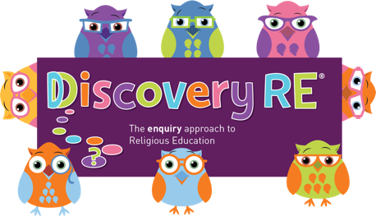
Discovery RE Knowledge Organiser
This knowledge organiser is a guide, offering key information to point the teacher in the right direction as to the beliefs underpinning the particular enquiry.
The summaries must not be taken as the beliefs of ALL members of the particular religion.
Religion /Worldview: Hinduism | Enquiry Question: Do beliefs in Karma, Samsara and Moksha help Hindus lead good lives? | Age: 9/10 Year Group: 5 Summer 1
In this enquiry, the children look at the key beliefs concerning the cycle of life, death and rebirth. They consider the importance of doing good deeds.

Core Knowledge (see also background information documents) |  | Link to other aspects of belief | Personal connection / resonance
This enquiry looks at some key concepts surrounding the cycle of life, death and reincarnation  Samsara  Hindus believe in reincarnation, the cycle of rebirth - a belief that the soul lives many lifetimes, in one body after another.  Karma  Karma can be translated as actions and in a broad sense explains that our actions have consequences. Hindus believe that the soul passes through a cycle of many lives and the next life is always dependent on how the previous life was lived.  Moksha  The spiritual goal of a Hindu is to become one with Brahman.  Moksha is linked closely to karma as the actions a person undertakes have a direct influence on their next life, so to achieve Moksha, good Karma must be accumulated.  Some Hindus separate themselves from ordinary life to pursue a spiritual journey |  | - Link Karma to the actions of Prince Rama in the Ramayana story – celebrated at Divali  - Pilgrimage to the Ganges – would it bring good karma? | - What good actions could I do?  - What might happen if I do good things?  - Will it help me if I do good things?  - Why is it important to not always expect a reward?  - What do I think happens at the end of life?
Key Terms and definitions | History/Context | Impact on believer/daily life | Spiral curriculum link
Karma: actions and in particular the consequences of our actions in this life and the next  Samsara: the cycle of life including birth, life, death and rebirth  Moksha: the final release from the cycle of rebirth – to join with Brahman  Sadhu: a Holy man – usually one who has turned away from ordinary life to concentrate on spiritual matters | - Karma (actions) - traditionally linked to dharma (duties) that needed to be performed. These duties were defined by the caste system which decided what class you were in and what jobs you would do. Performing these duties well would improve your chances of a better next life.  - Many Hindus now do not recognise the caste system but still value good karma | - The cycle of rebirth should be in a Hindu’s mind each day as everything we do will have a consequence either in this life or the next  - This belief would also prompt Hindus to help others around them be the best they can be – to help them attain the best situation next time | This unit brings together aspects of all the previous units as it concerns actions and their consequences. It will refer to belief in Brahman, how people live their lives, show commitment and prepare for what happens after this life is over.
Home learning ideas/questions:
How could we help each other? How could we help others around us? How could we help people we do not know, who are in need?

© 2020 Discovery RE Ltd

