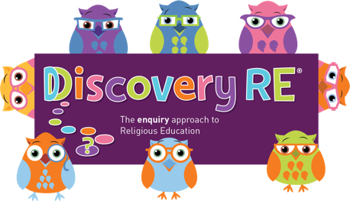
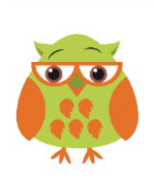
Discovery RE Knowledge Organiser
This knowledge organiser is a guide, offering key information to point the teacher in the right direction as to the beliefs underpinning the particular enquiry.
The summaries must not be taken as the beliefs of ALL members of the particular religion.
Religion /Worldview: Hinduism | Enquiry Question: How can Brahman be everywhere and in everything? | Age: 9/10 Year Group 5 Spring 1
In this enquiry, the children look at the Hindu belief that we all have a part of Brahman within us. They will consider how this belief could impact on their lives and the choices they make

Core Knowledge (see also background information documents) |  | Link to other aspects of belief | Personal connection / resonance
Hindus believe in a universal soul or God called Brahman and that there is a part of Brahman in everyone and this is called the Atman  Atman  - The atman is translated into English as the eternal self, spirit, essence, soul, or breath. It is the true self which moves on after death or becomes part of Brahman (the force underlying all things).  - The final stage of moksha (liberation) is the understanding that your atman is, in fact, Brahman.  Trimurti  Trimurti, a term meaning "having three forms," refers to the three main aspects of Brahman. |  | - The Caste system  - Karma – actions  - Dharma – duties that need to be performed  - Personal choice of deities to worship  - Pilgrimage to the Ganges (a way to help achieve Moksha) | - What do I think about a soul?  - How am I unique?  - Why is it a good to be me?  - How can I use my strengths to help others?
Key Terms and definitions | History/Context | Impact on believer/daily life | Spiral curriculum link
Atman: eternal self  Trimurti: three deities working together to reflect the laws of nature - namely  - Brahma: creator  - Vishnu: preserver  - Shiva: destroyer | The cycle of life and death has always been a key part of Hindu beliefs. Accepting your place in life and the part you should play was crucial to the proper working of society through the caste system. This is not so popular now particularly in the western world. | - Beliefs about your own place in the cycle of life and death influence daily life  - What actions will bring the greater chance of a better life next time?  - What duties should a Hindu perform?  - Do they believe in the caste system? | This enquiry builds on prior Year 3 enquiries.  A deeper understanding of the connection between each person and Brahman should result from this enquiry
Home learning ideas/questions:
What do we think is the meaning of life? How can we make the best decisions to look after the people around us? Can we list each other’s strengths?

© 2020 Discovery RE Ltd

