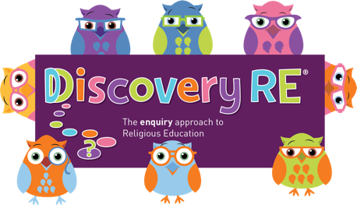
Discovery RE Knowledge Organiser
This knowledge organiser is a guide, offering key information to point the teacher in the right direction as to the beliefs underpinning the particular enquiry.
The summaries must not be taken as the beliefs of ALL members of the particular religion.
Religion /Worldview: Christianity | Enquiry Question: Is the Christmas story true? | Age: 9/10 Year Group: 5 Autumn 2
This enquiry asks the children to investigate whether a sacred text has to be “true” to help a believer understand their religion.

Core Knowledge (see also background information documents) |  | Link to other aspects of belief | Personal connection / resonance
- The Bible records the important events in the life of Jesus in the Gospels.  - The Gospels were probably not written as events happened. They would have been told and retold before recording, therefore specific dates and times may have become unknown (or irrelevant)  - The fixing of a festival date to commemorate an event does not necessarily have to happen on the actual date of the event (e.g. The Scouting/Guiding movement chose the birthday of the founders, not the actual date they first started the movement).  - The Gospels which retell the birth of Jesus agree on the main points and disagree on nothing. |  | - Trinity. This is the complete relationship between God (the Father), Jesus (his son) and the Holy Spirit. The three are “consubstantial”, which means that they exist separately and together as one.  - Incarnation: God becoming man or literally being “made flesh”.  - What does ‘truth’ mean?…historic fact, scientific truth, personal truth i.e. belief/faith? | - What do I believe about Christmas? Do I need to believe the story is true to celebrate at Christmas time if I want to?  - Are there other stories I have learnt about that may or may not be true? Does it matter or is it more important that I understand the message in the story?
Key Terms and definitions | History/Context | Impact on believer/daily life | Spiral curriculum link
Gospels: literally means “good news”, books of the New Testament recounting Jesus’ life.  Gospel ‘writers’: Matthew, Mark, Luke and John – four of Jesus’ disciples.  Disciples: Jesus’ special friends  Truth: historic fact, scientific truth, personal truth i.e. belief/faith? | There are some factors within the story which are less likely to point to December being the month in which Jesus was actually born. For example, the sheep being out in the fields, suggest the weather would have been warmer, so he may have been born in the spring. | The Christmas story is a basis for belief for millions of Christians across the world and has been widely believed by the Christian Church for millennia. Having four biblical accounts of Jesus’ life, including two of his birth, is seen as being incredibly enriching to a Christian’s understanding of what happened and what it means. People notice different elements of a scene and recount it in their own way. Therefore, the definition of “true” would depend on the writer, and the understanding of the person reading the account, as well as on a person’s definition of ‘truth’. | All previous Christmas units.  Also, the optional Year 4 unit on the Gospels would be a good basis for the children to understand the fact that the Gospels were not written immediately and differ due to the different viewpoint of the writer/narrator, but that Christians believe them to be ‘true’.
Home learning ideas/questions:
Are there any other things we think of as “true” for us that other people may not believe in? Does it matter?

© 2020 Discovery RE Ltd

