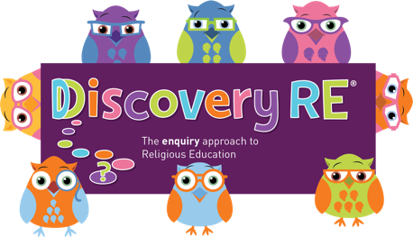
Discovery RE Knowledge Organiser
This knowledge organiser is a guide, offering key information to point the teacher in the right direction as to the beliefs underpinning the particular enquiry.
The summaries must not be taken as the beliefs of ALL members of the particular religion.
Religion /Worldview: Christianity | Enquiry Question: Do people need to go to church to show they are Christians? | Age: 8/9 Year Group: 4 Summer 2
This enquiry looks at some of the rites (or Sacraments) that are performed in churches (the Christian place of worship) and investigates how and why Christians might choose to worship in a church (rather than e.g. just pray at home).

Core Knowledge (see also background information documents) |  | Link to other aspects of belief | Personal connection / resonance
Jesus taught about worship in the Bible and praying .  Baptism is generally a rite for babies although adults can choose to be baptised later in life. It confers the name of the person and their part in God’s family.  Many Christians would choose to get married in church to confer God’s blessing on the marriage.  Churches frequently have art or symbols which may remind the Christian of his or her beliefs or the life of Jesus or other figures from the Bible or later saints. These can help the Christian focus when in church which they may find more difficult e.g. at home where there are more distractions.  Consider the feelings a place evokes as well as the building and what happens there. These feelings may be one of the reasons a Christian would choose to go to church. |  | Love of God and love of neighbour can be demonstrated by a Christian through service to the Church and its community (e.g. arranging flowers, reading, taking communion to the sick, contributing to music etc). Other Christians will consider it most important to do good work in the community as well as or instead of helping specifically in the church building or services. These were the commandments given by Jesus in Matthew 22:37-40. | - Do I have a special place?  - Are there actions or events that can only happen in my special place? Why? What is special about them to me?  - Does it feel better to celebrate something or to do something special with other people who feel the same way as I do, or do I prefer to have special moments in private?
Key Terms and definitions | History/Context | Impact on believer/daily life | Spiral curriculum link
Sacraments: rites which are often performed in Churches such as marriages, baptisms and communion/Eucharist.  Eucharist/Communion: the taking of bread and wine in remembrance of the events of the Last Supper  Saints: Holy people recognised by the Church because of actions in their lives, miracles or the examples they set. | Whilst Holy Communion or Eucharist is usually carried out in church, it should be noted that people who wish to but cannot come to church e.g. because they are sick, can receive communion from a minister who can take it to them. However, for many Christians, the receiving of communion will be the biggest difference between praying and worshipping at home (or away from the church) and attending a service in church where Eucharist is distributed. | Although many Christians will attend church, the regularity and reasons for attending may vary hugely. Some Christians will attend weekly or even daily to pray and receive communion. Some will attend only for larger festivals such as Christmas and Easter or for family events such as weddings, baptisms or funerals. Some Christians will only pray when they go to church, others will also pray at home on a regular or more ad hoc basis. | The Yr5 Summer 2 enquiry builds on this by pulling together all learning about Christianity so far in its discussion about wider commitment including church attendance.
Home learning ideas/questions: If we have ever been to an event at or visited a place of worship (a church or building from another religion) what did we feel about it? Do we have special places we go as a family/household because they have special significance to us? What are they and why are they special?
© 2020 Discovery RE Ltd

