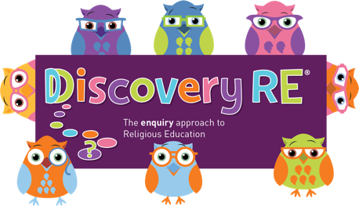
Discovery RE Knowledge Organiser
This knowledge organiser is a guide, offering key information to point the teacher in the right direction as to the beliefs underpinning the particular enquiry.
The summaries must not be taken as the beliefs of ALL members of the particular religion.
Religion /Worldview: Buddhism | Enquiry Question: What is the best way for a Buddhist to lead a good life? | Age: 8/9 Year Group: 4 Summer 1
In this enquiry, the children talk about how Buddhists try to lead a good life according to the Buddha’s teachings. They reflect on how this may impact on their own lives if they chose to follow these teachings themselves.

Core Knowledge (see also background information documents) |  | Link to other aspects of belief | Personal connection / resonance
The focus of this enquiry is an in-depth look at the Noble Eightfold Path  Noble Eightfold Path  • Right Viewpoint – You should look at life in the right way (i.e. being positive)  • Right Thought - You should think about others, not just yourself  • Right Speech – You should talk to people properly, with respect  • Right Action – You should act in a way that does not hurt people e.g. no killing or stealing  • Right Living – Your job must help, not harm other people or animals  • Right Effort - You should do the best that you can  • Right Awareness - You should be sensitive to the needs of others - think about those around you  • Right Concentration - You should focus your mind on what needs to be done - especially solving problems - Concentrate by using meditation |  | The Four Noble Truths  - Dukkha (usually translated as suffering) exists – such as sickness and death, and also in things that are pleasing, because the pleasure will end.  - Dukkha is caused by craving. This keeps us constantly wanting more and not being satisfied – this creates suffering  - Dukkha can be stopped. People do not need to be greedy and selfish and do not need to sufffer  - The way to end Dukkha is by following the Noble Eightfold Path  The Five precepts  - To harm no living thing  - To not take what is not given  - To not use false speech  - To not take intoxicants  - To refrain from sexual misconduct | - Do I lead a good life?  - Could any of these teachings help me improve as a person?  - Which of these teachings would I need help with?  - How could I get help to improve?
Key Terms and definitions | History/Context | Impact on believer/daily life | Spiral curriculum link
Dukkha: Suffering | Many Buddhists do not believe in a god, instead they believe in using the Buddha’s teachings to help them be in the right frame of mind to think, say and do things that are not going to cause suffering. | Buddhists try to follow the path in significant matters, for example, choosing their job. It must be a job that helps and causes no harm. This is a personal daily struggle for Buddhists in the modern world. | Building on the previous 2 Yr 4 lessons starting with the Buddha’s story – exploring how the Eightfold path could help lead to enlightenment.
Home learning ideas/questions:
What could I do at home to be a better person? How could I improve my speech? My actions? My attitude? What impact would this have at home and in life?

© 2020 Discovery RE Ltd

