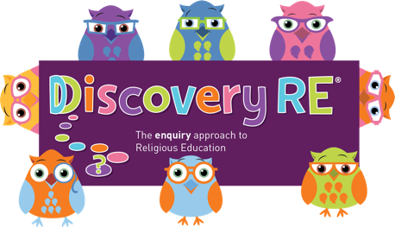
Discovery RE Knowledge Organiser
This knowledge organiser is a guide, offering key information to point the teacher in the right direction as to the beliefs underpinning the particular enquiry.
The summaries must not be taken as the beliefs of ALL members of the particular religion.
Religion /Worldview: Christianity | Enquiry Question: Is forgiveness always possible for Christians? | Age: 8/9 Year Group: 4 Spring 2
This enquiry investigates how Jesus’ life, death and resurrection impacts on a Christian’s understanding of forgiveness.

Core Knowledge (see also background information documents) |  | Link to other aspects of belief | Personal connection / resonance
Christians believe that Jesus is the son of God, who came to Earth in order to save humans from their sins. His death and resurrection opened up the way back to God and restored humanity’s relationship with him. This is the Christian concept of salvation.  Jesus forgave many people in his lifetime as an example to his followers. He was “without sin” as the incarnate Son of God so could not do something wrong. He is usually depicted in the Gospels as kind and loving. The actions in the Temple are a stark contrast to this.  Jesus taught his disciples “the Lord’s Prayer” which is also known as the “Our Father”. It explicitly asks God to grant the speaker forgiveness as they forgive others who have hurt them. |  | - Jesus as the Son of God has the power to forgive sins.  - Jesus’ death and resurrection which is celebrated by Christians at Easter. Christians believe that Jesus choosing to go to his death is atoning for all wrongdoing in the world and they are therefore also forgiven of any sins. | - How do I feel about forgiving people? Is it something I find easy to do or do I find it difficult?  - Is it easier to forgive some actions than others? Do I think some people deserve forgiveness and some don’t?  - What might I need to be forgiven for?
Key Terms and definitions | History/Context | Impact on believer/daily life | Spiral curriculum link
Incarnation: God becoming man or literally being “made flesh  Gospel: the first 4 books of the New Testament about Jesus’ life, ministry and death, and the early Church.  Disciples: Jesus’s special friends.  Lamb of God: A name given to Jesus because he sacrificed himself as animals were sacrificed at the time. | The reference to Jesus overturning the traders’ tables in the Temple might cause children to think Jesus’ actions were unforgiving, but the Temple was meant to be a place of prayer and peace. Instead of this, there is the bellowing of cattle and the bleating of sheep and the voices of the traders making money from a holy act in a holy place. These animals were being sold in order to be ritually sacrificed. | Many Christians will be aware of and may regularly say “The Lord’s Prayer”. The Christian asks God to forgive his or her wrongdoing as they forgive people who have wronged them, implying that God expects the Christian to practice forgiveness towards all others. | Builds on previous Easter enquiries.  Also links to ‘agape’ (love) from Yr 2 Autumn 2 in that Christians believe that Jesus selflessly gave himself for their salvation, which is also studied in the Yr 6 optional enquiry.  Yr 5 summer 2 talks about Christian beliefs and practices and forgiveness would be an important part of this.
Home learning ideas/questions: What do we think about forgiveness? Is it something we try to do at home? Is it easy or difficult? Does loving somebody make it easier or more difficult to forgive them if they hurt us?

© 2020 Discovery RE Ltd

