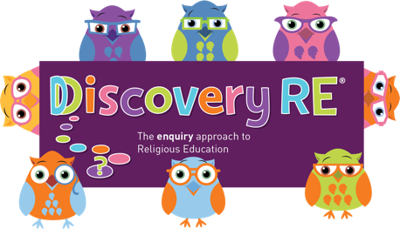
Discovery RE Knowledge Organiser
This knowledge organiser is a guide, offering key information to point the teacher in the right direction as to the beliefs underpinning the particular enquiry.
The summaries must not be taken as the beliefs of ALL members of the particular religion.
Religion /Worldview: Buddhism | Enquiry Question: Could the Buddha’s teachings make the world a better place? | Age: 8/9 Year Group: 4 Spring 1
This enquiry focusses on key teachings given by the Buddha and the children have the opportunity to consider how they could apply some of these to their own life

Core Knowledge (see also background information documents) |  | Link to other aspects of belief | Personal connection / resonance
The focus of this unit is some of the Buddha’s teachings namely the Three Marks of Existence and the Noble Eightfold Path  The Three Marks of Existence/universal truths (enquiry focus is on the first 2)  - Dukkha (suffering) is everywhere all the time  - Anicca – the belief that nothing lasts, everything changes  - Anatta (the belief that there is no ‘self’).  Noble Eightfold Path  - Right Viewpoint – You should look at life in the right way (i.e. being positive)  - Right Thought - You should think about others, not just yourself  - Right Speech – You should talk to people properly, with respect  - Right Action – You should act in a way that does not hurt people e.g. no stealing  - Right Living – Your job must help, not harm other people or animals  - Right Effort - You should do the best that you can  - Right Awareness - You should be sensitive to the needs of others  Right Concentration - You should focus your mind on what needs to be done - especially solving problems - Concentrate by using meditation |  | - Four Noble Truths  - Five Precepts  - Nirvana | - What do I think would make the world a better place?  - How could I use Right Speech?  - What Right Actions could I do?  - How do I feel about changes in life?
Key Terms and definitions | History/Context | Impact on believer/daily life | Spiral curriculum link
Dukkha: (suffering) is everywhere all the time  Anicca: the belief that nothing lasts, everything changes  Anatta: the belief that there is no ‘self’ | Wherever Buddhists live they will need to apply the teachings to the society they live in e.g. Western society can find talking about death difficult whereas it is a part of life for Buddhists | The teachings focus on two key points  1. They have to understand and accept some difficult truths about life  2. They have a responsibility for our own thoughts, words, and deeds and for the impact they have | This enquiry refers back to the life of the Buddha in the first enquiry (Yr4 Autumn 1). Recap the story and the impact of the 4 sights on the prince.
Home learning ideas/questions: What could we put more effort into? Could we use kind speech a little more? What impact would this have in our homes and lives?

© 2020 Discovery RE Ltd

