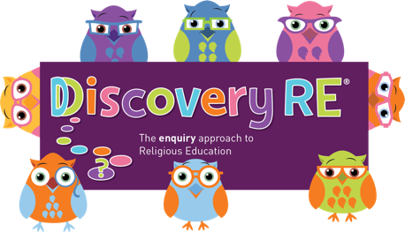
Discovery RE Knowledge Organiser
This knowledge organiser is a guide, offering key information to point the teacher in the right direction as to the beliefs underpinning the particular enquiry.
The summaries must not be taken as the beliefs of ALL members of the particular religion.
Religion /Worldview: Christianity | Enquiry Question: What is the most significant part of the nativity story for Christians today? | Age: 8/9 Year Group: 4 Autumn 2
This enquiry investigates the significance and symbolism of elements of the Christmas story to Christians today.

Core Knowledge (see also background information documents) |  | Link to other aspects of belief | Personal connection / resonance
- Jesus was born in Bethlehem and Christians believe he was God’s son. Mary was his mother and Joseph was engaged to her at the time.  - The elements of the Christingle have a symbolism  - The orange represents the world.  - The candle reminds Christians of Jesus whom they believe to be the light of the world.  - The red ribbon goes all round the 'world' and being the colour of blood, reminds Christians that Jesus died.  - The four cocktail sticks are the four seasons  - The sweets (or sometimes dried fruit) remind Christians of God's gifts to the world |  | - Jesus as the Son of God and light of the world – leading Christians to God hence the star and the candle in the Christingle.  - The Annunciation: that Mary agreed to the Angel Gabriel’s request when God sent him to ask her to be the mother of Jesus. | - What symbols are meaningful to me?  - What could I use as symbols to portray things that are important to me in my life?  - Is it important that others understand my symbolism or is it something personal that only I comprehend?
Key Terms and definitions | History/Context | Impact on believer/daily life | Spiral curriculum link
Incarnation: God becoming man or literally being “made flesh  Christingle: An ornament made in many homes and church at Christmas with significance to each part of it. | See Yr3 Autumn 2 for the contextual significance of the shepherds.  The Christingle (which means “Christ-light”) started in Germany in 1747. The tradition spread with the movement of the church. In 1968 the Christingle Service was brought to the Anglican Church of England although many different denominations now use it. | - Symbols are still used today e.g. the Christingles, a star or angel on the top of the Christmas tree.  - Christians may also have a “crib” or nativity scene in their own home to remind them of the elements of the Christmas story.  - Many Christians will attend Church services over the Christmas period to commemorate the birth of Jesus. | Builds on previous Christmas enquiries, especially on the symbolism of the aspects of the Christmas story discussed in Yr3 Autumn 2.
Home learning ideas/questions: Could our household make a Christingle or some other symbolic home decoration which shows the things that are important to us in our lives? Can we discuss what is important to each of us and to us all?

© 2020 Discovery RE Ltd

