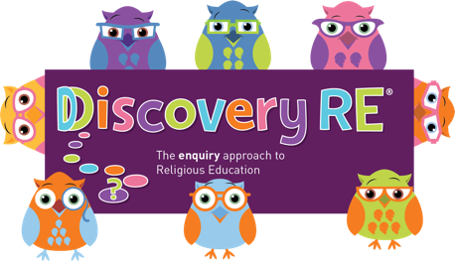
Discovery RE Knowledge Organiser Year 3, ages 7-8
Religion /Worldview: Sikhism | Enquiry Question: What is the best way for a Sikh to show commitment to God? | Age: 7/8 Year Group: 3 Summer 2
In this enquiries, the children talk about different Sikh practices and rank them according to which they feel show the most commitment whilst recognising that all are important
This knowledge organiser is a guide, offering key information to point the teacher in the right direction as to the beliefs underpinning the particular enquiry.
The summaries must not be taken as the beliefs of ALL members of the particular religion.

Core Knowledge (see also background information documents) |  | Link to other aspects of belief | Personal connection / resonance
Sikhs are proud to visibly show commitment to their faith – this can be done in many ways including  - Joining the Khalsa through the Amrit Ceremony  - Wearing the 5 K’s  - Worshipping in the Gurdwara  - Reading and respecting the Guru Granth Sahib  - Serving the community through the Langar meal and other areas of Sewa (service) |  | - Treatment of the Guru Granth Sahib in the Gurdwara  - Worship in the Gurdwara  - Langar  - Sewa (selfless service) / Vand Chakna (sharing with others) | - How do I show commitment to people I care about?  - How do I show commitment to things that are important to me?
Key Terms and definitions | History/Context | Impact on believer/daily life | Spiral curriculum link
Waheguru: God  Mool Mantar: This is the opening text of the Guru Granth Sahib – ‘ik onkar’ – There is only one God  The Guru Granth Sahib: Holy book  Chauri: fan used to show respect to the Guru Granth Sahib  Granthi: person who reads the Guru Granth Sahib | The tenth Guru, Guru Gobind Singh said that there would be no other living Gurus after him so Sikhs should look to their holy scriptures for guidance instead. The Guru Granth Sahib is this scripture, and is treated as the living Guru of the Sikhs.  Mool Mantar  Sikhs believe that Waheguru's (God) nature is expressed in the Mool Mantar. The first line of the Mool Mantar is “Ik Onkar”, which means “There is only one God”. | - The symbol meaning “Ik Onkar” is seen in Gurdwaras and Sikh homes.  - This symbolises the oneness of God and the oneness of humanity (the belief that everyone is equal). Treating people equally is vital to Sikhs | Lesson 3 on Sikhism – referring back to previous learning on the Khalsa and Sikh beliefs around sharing is essential to ensure the children can fully understand the importance of commitment.
Home learning ideas/questions:
How do we show commitment to people we care about? What can we share? How does sharing make us feel?

© 2020 Discovery RE Ltd

