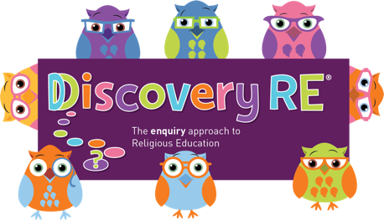
Discovery RE Knowledge Organiser Year 3, ages 7-8
This knowledge organiser is a guide, offering key information to point the teacher in the right direction as to the beliefs underpinning the particular enquiry.
The summaries must not be taken as the beliefs of ALL members of the particular religion.

Religion /Worldview: Sikhism | Enquiry Question: Do Sikhs think it is important to share? | Age: 7/8 Year Group: 3 Summer 1
In this enquiry, the children learn about why sharing is so important to Sikhs. They look at key festivals and begin to understand how important the community is to Sikhs. Keeping the stories fresh in their minds helps Sikhs live their daily lives in what they believe is the correct way.

Core Knowledge (see also background information documents) |  | Link to other aspects of belief | Personal connection / resonance
- Sharing is a key part of Sikh beliefs and practice – the enquiry looks at some festivals and practices which include an element of sharing.  - Vaisakhi – this remembers the beginning of the Khalsa (refer back to first lesson)  - The Place of Worship, The Gurdwara, is a focus of the festival celebrations – the community are involved fully  - Celebrations include – singing, music, reading from the holy book, hymn chanting and community care  - The Guru Granth Sahib is seen as a living teacher and treated with great respect  - Divali – a festival commemorating the story of Guru Gobind Singh – a story of sharing and humanitarianism  - Divali can be celebrated in different ways in different parts of the world – lights are often part of the festivities |  | - Sikhs believe in standing up to injustice – many examples through history of this occurring  - How the Guru Granth Sahib is respected and looked after in the Gurdwara  - Khalsa – how joining the Khalsa keeps alive the important beliefs and stories  - The Langar is an important part of Sikh life not just at festival times. The langar is the free meal provided for anyone who enters the Gurdwara. It is provided for by the community who take it in turns to prepare it and serve people. | - What do I think about sharing? Do I share? Could I share more?  - Why is it good to help people in need?  - Why is it important to stand up against things that are wrong? What would I protest about?
Key Terms and definitions | History/Context | Impact on believer/daily life | Spiral curriculum link
Vaisakhi – festival commemorating the Khalsa  Gurdwara – Sikh place of Worship  Guru Granth Sahib – Sikh holy book  Divali – festival commemorating the release of one of the 10 Gurus  Langar – a free meal given to all who come to the Gurdwara – usually vegetarian so everyone can have it | - Vaisakhi essentially celebrates the start of Sikhism as an organised religion of committed believers  - Divali commemorates how one of the Gurus endured suffering yet still thought of others and not just his own situation | - The example set by the Gurus in the two festivals inspires Sikhs to take part in Sewa – selfless service  - Sikhs believe they have a responsibility to live a good life and challenge injustice like the Gurus did. | This is the second lesson on Sikhism and follows on from the learning of the first. Ensure that some key parts of lesson one about the khalsa are revisited e.g. the story of the Khalsa and the 5 K’s symbolism
Home learning ideas/questions: What examples of sharing do you practice at home? Why is this a good thing to do? What else could you do?
Are there any issues you think you would want to protest about or stand up to?

© 2020 Discovery RE Ltd

