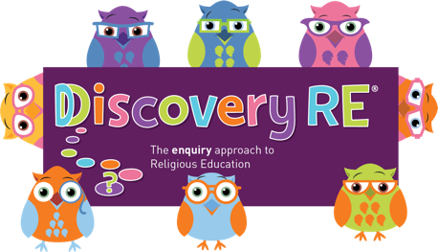
Discovery RE Knowledge Organiser Year 3, ages 7-8
This knowledge organiser is a guide, offering key information to point the teacher in the right direction as to the beliefs underpinning the particular enquiry.
The summaries must not be taken as the beliefs of ALL members of the particular religion.
Religion /Worldview: Christianity | Enquiry Question: What is good about Good Friday? | Age: 7/8 Year Group: 3 Spring 2
This enquiry considers the Christian concepts of Salvation and the Gospels, where we find the story of Holy Week (the events leading up to Jesus’ death and resurrection starting with Palm Sunday and finishing on Easter Sunday).

Core Knowledge (see also background information documents) |  | Link to other aspects of belief | Personal connection / resonance
Salvation: the belief that Jesus’ death and resurrection saved humans and opened the way back to God for eternity.  All 4 of the Gospels (the accounts of Jesus’ life on earth attributed to his closest friends) tell the story of Holy Week. The day before Good Friday is called “Maundy Thursday” and is the day he ate a “Last Supper” with his friends. The passing of the cup of wine and breaking of bread at this supper is commemorated in the Christian sacrament of communion. Good Friday is the day when Christians commemorate the death of Jesus on the cross. Christians believe his death on Good Friday was necessary to bring forth the resurrection on Easter Sunday. |  | The word Gospel means “good news” as Christians believe Jesus’ incarnation (God becoming man) is good news for all people.  Christians believe that Jesus went willingly to his death because he trusted God as his father.  They believe in eternal life with God because of Jesus rising from the dead. | Can I consider a belief where somebody comes back to life from the dead and which therefore makes their death a “good” thing? How do I feel about this?
Key Terms and definitions | History/Context | Impact on believer/daily life | Spiral curriculum link
Incarnation: God as man  Disciples: Jesus’ special friends  Resurrection: Coming back to life after being put to death  Crucifixion: being put to death by being nailed to a cross.  Communion: The sharing of specially blessed bread and wine which then becomes/represents to Christians the body and blood of Jesus to commemorate the Last Supper and Jesus’ death and resurrection. | Crucifixion was a common punishment for certain crimes in Jesus’ times. The Bible says Jesus was put to death along with two thieves.  Jesus fulfilled many prophecies from the Old Testament throughout his life, but especially over Holy Week. These allowed his disciples, who would have known these verses, to have even more belief that he was the long-awaited Messiah. | Christians believe that it was God’s plan that Jesus was to suffer death in this way to show that people can be forgiven and have a fresh start. Jesus forgave the thief and bystanders at his crucifixion.  Many Christians will go regularly to church to share in communion in memory of the death and resurrection of Christ and Christians who do not attend more regularly may go to the Easter services on Maundy Thursday, Good Friday and Easter Sunday. | Yrs 1&2 Spring 2 Easter units.  Other units which speak of sacrifice for faith such as Yr 1 Summer 1 (Judaism: Shabbat), Yr 3 Spring 1 (Sikhism: the story of the Khalsa).
Home learning ideas/questions:
Do my family know about the Christian belief commemorated at Easter? What do we do to celebrate Easter, if anything?

© 2020 Discovery RE Ltd

