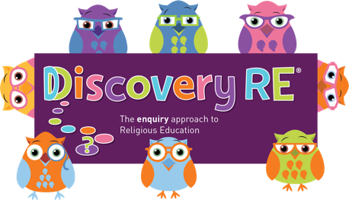
Discovery RE Knowledge Organiser Year 3, ages 7-8
This knowledge organiser is a guide, offering key information to point the teacher in the right direction as to the beliefs underpinning the particular enquiry.
The summaries must not be taken as the beliefs of ALL members of the particular religion.
Religion /Worldview: Christianity | Enquiry Question: Could Jesus heal people? Were these miracles or is there some other explanation? | Age: 7/8 Year Group: 3 Spring 1
This enquiry investigates two miracles of Jesus where healing took place and children evaluate whether they think they were miracles or if there could be another explanation.

Core Knowledge (see also background information documents) |  | Link to other aspects of belief | Personal connection / resonance
The concept of Incarnation is that Jesus became man and lived among men and women. As part of his ministry, narrated in the New Testament of the Bible, Jesus performed many miracles.  The two included in this enquiry are based on healing (rather than some others which create e.g. food and drink).  Jesus uses saliva to heal the man born blind and builds on the faith of the friends to heal a paralysed man. |  | Trinity – relationship between God (the Father), Jesus (his son) and the Holy Spirit. The three are “consubstantial”, which means that they exist separately and together as one. This gives Jesus the power to perform miracles.  Other miracles such as the healing of the dumb man and the other blind man, also show his power to heal.  Belief in Jesus being eternal can impact on prayer for miracles. Miracles have been documented by the church in the time since Jesus left the earth. | How do I feel about miracles both then and now?  Can I think of any modern-day occurrences which could be described as, or which I believe to be, miraculous?
Key Terms and definitions | History/Context | Impact on believer/daily life | Spiral curriculum link
Incarnation: God as man  Disciples: Jesus’ special friends  Miracles: acts that Jesus performed during his lifetime which evidence to believers that he was truly God.  Pharisee: Strict follower of the Jewish faith  Baths: Areas for cleansing near the temple where there would also be beggars asking for money due to afflictions. | The people at the time believed that if parents did wrong (sinned) then children could be born with afflictions, hence the disciples asking about this.  Saliva was thought to possess medicinal qualities, but it was not believed by the people of Jesus' day to cure a man born blind, so it was deemed to be a miracle. | Their belief in the Trinity means that Christians understand Jesus to have powers that no ordinary man could, because he is one with God. They may pray to Jesus or God to perform miracles today as they believe he is eternal and with them in their daily lives and can help with problems. | Yr 2 Autumn 1: Jesus’ parables and miracles.  The optional Yr 1 Judaism enquiry shows that God (the Father) performed miracles before Jesus was born so this can be linked to the Christian belief that Jesus is his son.
Home learning ideas/questions:
What do we feel about miracles? Can they be explained in any other way? Do we think they ever happen today?

© 2020 Discovery RE Ltd

