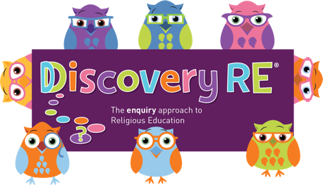
Discovery RE Knowledge Organiser Year 3, ages 7-8
This knowledge organiser is a guide, offering key information to point the teacher in the right direction as to the beliefs underpinning the particular enquiry.
The summaries must not be taken as the beliefs of ALL members of the particular religion.
Religion /Worldview: Christianity | Enquiry Question: Has Christmas lost its true meaning? | Age: 7/8 Year Group: 3 Autumn 2
This enquiry investigates the meaning of Christmas to Christians and examines the elements we see both with the Christmas story in the Bible, and Christmas today

Core Knowledge (see also background information documents) |  | Link to other aspects of belief | Personal connection / resonance
God chose a Jewish young woman called Mary, who was engaged to Joseph the carpenter, to be the mother of his earthly son.  He sent his angel, Gabriel, to ask this of her. Mary agreed to allow this to happen and Jesus was born in Bethlehem. This is the Christian concept of “incarnation”: God becoming man or literally being “made flesh”. Jesus was born in a stable and was visited by a variety of people from very different social classes. There is a significance to the people and places which appear in the Christmas story (explained below). |  | - Trinity – relationship between God (the Father), Jesus (his son) and the Holy Spirit. The three are “consubstantial”, which means that they exist separately and together as one. | - Do I celebrate Christmas? What do I like about it if I do?  - Can I see a difference between what Christmas might mean to a Christian and what the more commercial messages are?  - What is important to me at this time of year?
Key Terms and definitions | History/Context | Impact on believer/daily life | Spiral curriculum link
Shepherds: first people to learn of the birth of Christ.  Star: The star led the wise men from a great distance to Jesus. It also portrays to Christians that Jesus is the light of the world.  Wise men and their gifts: The wise men travelled a great distance because the star signified to them that a king had been born. They chose gifts fit for royalty and which signified Jesus’ life to come (see Year 1 Autumn 2 for more details).  Stable: Earthly royalty would be born in a palace, but Jesus was born in a stable because there was no room at the inn. | In Jewish culture of the time, the shepherds were very lowly, because they had to sleep with the animals as part of their job. This made them outcasts from many religious activities because they were “unclean”.  The birth of Jesus was not how the Jews traditionally thought the Messiah would come and lead them. Because of the Roman occupation, they hoped a Messiah would be an earthly king who would free them. | That the shepherds were told first signifies to Christians that God loves the poor and outcast person.  The stable as a place of birth signifies to Christians that Jesus had no need of pomp or finery because he was not an earthly king. It is also an indication that there would be no room for Jesus in the lives of some people he would encounter in his life because they believed that he did not fit the traditional Jewish idea of the Messiah | Builds on previous Christmas enquiries from Years 1 & 2.
Home learning ideas/questions:
What do we feel about Christmas? How would we feel about important people such as our royalty if they had been born under similar conditions to Jesus? Does it matter that he had such a poor beginning, or do we think that it is what Christians believe now that matters?

© 2020 Discovery RE Ltd

