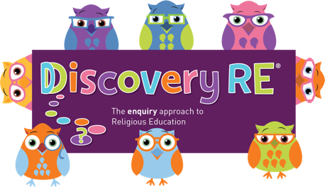
Discovery RE Knowledge Organiser Year 2, ages 6-7
This knowledge organiser is a guide, offering key information to point the teacher in the right direction as to the beliefs underpinning the particular enquiry.
The summaries must not be taken as the beliefs of ALL members of the particular religion.
Religion /Worldview: Islam | Enquiry Question: Does completing Hajj make a person a better Muslim? | Age: 6/7 Year Group: 2 Summer 2
In this enquiry, the children look at the Islamic pilgrimage to Makkah in Saudi Arabia. They learn about the important places; the things Muslims do and the reasons behind them.

Core Knowledge (see also background information documents) |  | Link to other aspects of belief | Personal connection / resonance
Hajj, the Pilgrimage to Makkah in Saudi Arabia, is one of the “Five Pillars of Islam” on which the Sunni Muslim faith is built. The other pillars are looked at in detail in Year 6, Summer 1 and 2  The Hajj takes place every year and it is the duty of every adult Muslim, who is physically and mentally fit and can afford it, to make the pilgrimage at least once in a lifetime.  The Hajj commemorates some major events in the early years of the faith and marks the start of the success of Islam.  When on pilgrimage, Muslims put away their usual clothes and outward signs of wealth, the vast majority wear white seamless garments known as Ihram. This symbolises equality, a key Islamic belief. |  | - Prophethood – the role of a prophet  - The Prophet Muhammad and the Qur’an – how it was revealed and the journey from Makkah to Madinah  - Festival of Sacrifice – Eid-ul-Adha  - Ways to afford going on Hajj | - If I was going on a special journey why would it be important to be prepared?  - How could I show respect to someone or something important?  - Why is it important that everyone looks the same? How is it like wearing school uniform?
Key Terms and definitions | History/Context | Impact on believer/daily life | Spiral curriculum link
Makkah: Holy city in Saudi Arabia – pilgrimage site  Hajj: pilgrimage  Ihram: a state of equality including plain clothing worn on pilgrimage  Qur’an: Holy Book – word of Allah  Muhammad: the final prophet of Islam | - The pilgrimage involves commemorating stories involving prophets like Adam, Ibrahim (Abraham) and Muhammad.  - This worldwide gathering of Muslims from many different cultures shows the true meaning of Ummah – the Muslim community | The Hajj to Makkah is a once in a lifetime requirement, Muslims must be able to get the money honestly without borrowing it, so many families save up to send one member at a time.  One of the key parts of the hajj is to stand before God and ask for forgiveness for everything you have done wrong. Daily life will be building up to this moment. | Refer to the 2 previous lessons on prayer and the Mosque. This enquiry looks at the significance of Makkah and the events that took place here in Muslim History. The pilgrimage gives pilgrims the chance to stand before Allah and ask forgiveness for their sins.  The Yr6 Autumn 1 enquiry builds on the learning in this enquiry.
Home learning ideas/questions: What places are special to us? What family events do we celebrate? How much of our family history do we know and remember?

© 2020 Discovery RE Ltd

