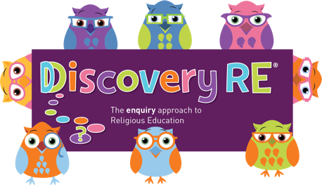
Discovery RE Knowledge Organiser Year 2, ages 6-7
This knowledge organiser is a guide, offering key information to point the teacher in the right direction as to the beliefs underpinning the particular enquiry.
The summaries must not be taken as the beliefs of ALL members of the particular religion.
Religion /Worldview: Islam | Enquiry Question: Does going to a Mosque give Muslims a sense of belonging? | Age: 6/7 Year Group: 2 Summer 1
In this enquiry, the children look at the Mosque and how it features in worship. They will consider the significance of the design and the important role it plays in the community

Core Knowledge (see also background information documents) |  | Link to other aspects of belief | Personal connection / resonance
The Mosque is the Islamic place of worship and is the centre of the Muslim community.  Going to the Mosque helps give a sense of belonging as Muslims gather there to give thanks to Allah.  They wash before prayer with others and join their fellow Muslims praying on the floor of the prayer room as all are equal in the eyes of Allah.  Purpose built mosques are very recognisable from the outside with a  - large domed roof covering the main prayer hall  - tower called a minaret from which the Call to Prayer is made.  Inside the Mosques there is usually a  - Minbar (platform at the top of some stairs) for the Imam (prayer leader) to stand on when he gives his sermon.  - Mihrab, an indentation in the Qiblah wall. This wall signifies the direction of Makkah to which Muslims pray. |  | - Different types of Mosque  - Public v Private worship  - Community uses of the Mosque – e.g. Madrasah school for children to learn Arabic  - Muslim teachings on equality from the Qur’an and the example of Muhammad | - What places are special to me?  - How should people behave in holy buildings?  - Why is it important to be respectful in holy buildings?  - Why is it important for people to be treated equally?  - How could I show people that we are equal?
Key Terms and definitions | History/Context | Impact on believer/daily life | Spiral curriculum link
Mosque: Islamic place of worship  Ummah: Muslim community  Qiblah wall: faces Makkah  Minbar: stairs  Minaret: tower  Dome: semi-circular roof above the prayer hall | - Muslims believe they are all part of a worldwide community called the Ummah – this connects Muslims from all over the world.  - In non-Muslim majority countries Mosques are often converted buildings | - Having access to a Mosque is important for Muslims as the building is used for many community activities. Muslims will try to be involved in the upkeep of the Mosques and donate money to ensure it is maintained  - Friday early afternoon prayers are usually the main time Muslims will try to get to the Mosque for prayers | Refer to Yr2 Spring 1 and some key beliefs in Allah – wanting to show respect to Allah leads Muslims to wish to pray in a clean place.  Meeting together in the mosques and praying on the floor reinforces the belief that ‘All are equal in the eyes of Allah’ which is stated in the Qur’an
Home learning ideas/questions:
What special places do we have? How do we show respect to our special places?

© 2020 Discovery RE Ltd

