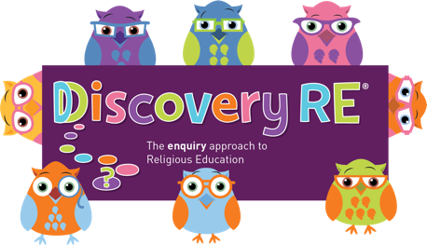
Discovery RE Knowledge Organiser Year 2, ages 6-7
This knowledge organiser is a guide, offering key information to point the teacher in the right direction as to the beliefs underpinning the particular enquiry.
The summaries must not be taken as the beliefs of ALL members of the particular religion.

Religion /Worldview: Christianity | Enquiry Question: How important is it to Christians that Jesus came back to life after his crucifixion | Age: 6/7 Year Group: 2 Spring 2
This enquiry examines the events of Easter Sunday, Jesus’ resurrection, and the impact this has on Christians today.

Core Knowledge (see also background information documents) |  | Link to other aspects of belief | Personal connection / resonance
Christians believe that Jesus was put to death on a cross and remember this event on Good Friday. They believe that after he died, he was put into a tomb with a stone rolled across the doorway (so something that could not easily be moved especially from the inside). On Easter Sunday, visitors to the tomb (one being Mary Magdalene who was a follower of Jesus) found it empty. Mary then saw Jesus in the gardens surrounding the tomb, demonstrating to her that he had risen from the dead.  The disciples (Jesus’ friends) wrote about these events and their significance in the later books of the New Testament |  | Acts of the Apostles and St Paul’s writings in the New Testament continue to refer to this event and will often be read in church.  Pentecost: 50 days after Easter Jesus appeared to his disciples having risen from the dead. | - What do I think about this belief – can I understand why it might be important to Christian?  - Can I imagine how it would feel to be loved by somebody so much that they would do anything to save me?
Key Terms and Definitions | History/Context | Impact on believer/daily life | Spiral curriculum link
Resurrection: rising from the dead  Salvation: the saving of mankind from permanent separation from God by the death and resurrection of Jesus, whom Christians believe is the Son of God  Disciples: Jesus’ special friends  New Testament: the part of the Bible which follows the birth of Jesus | Jesus was crucified because this was the law at the time. Because of the Roman occupation, Jews were not allowed to put a man to death, but they said he had blasphemed which was against their law, so the Romans agreed to kill him.  Jesus’ body had to be removed from the cross at sundown because of Old Testament Law in Deuteronomy which says anybody put to death for a crime should not stay there all night. | Christians believe that this shows that God as Jesus, could overcome even death. The Bible says that injuries that were sustained on the cross were still visible in Jesus after he had risen. These show a Christian that he had died as a human but that he had defeated this. So to Christians, the resurrection means that Jesus not only defeated death for himself, but that he defeated it for everybody, as a fellow human being. They also believe Jesus/God loved them enough to be hurt and die for them in the first place. | Builds on Year 1 Spring 2 Easter enquiry.  Also links to the love of agape from Yr 2 Autumn 2 in that Christians believe that Jesus selflessly gave himself for their salvation.
Home learning ideas/questions:
Do we know about or celebrate Easter? If so, what does it mean to the people I live with?

© 2020 Discovery RE Ltd

