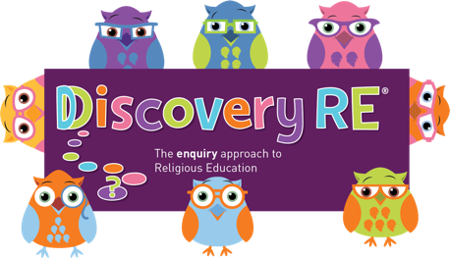
Discovery RE Knowledge Organiser Year 2, ages 6-7
This knowledge organiser is a guide, offering key information to point the teacher in the right direction as to the beliefs underpinning the particular enquiry.
The summaries must not be taken as the beliefs of ALL members of the particular religion.
Religion /Worldview: Islam | Enquiry Question: Does praying at regular intervals help a Muslim in his/her everyday life? | Age: 6/7 Year Group: 2 Spring 1
In this enquiry, the children look at Muslim beliefs about Prayer (mostly from a Sunni perspective). They will reflect on the movements, preparations and timings and consider why Prayer is so important.

Core Knowledge (see also background information documents) |  | Link to other aspects of belief | Personal connection / resonance
This enquiry focuses on Muslim worship, particularly prayer  There are different groups within Islam and practices concerning prayer differ- Sunni Muslims often pray 5 times a day whereas Shi’a Muslims can pray 3 times.  Many Muslims pray regularly ranging from early morning to last thing at night. Prayer is saying thanks to God. Muslims want to thank God for life and everything. Muslim life is built around worship of Allah (their name for God) through prayer.  The daily prayers (Salah) mean that Muslims pray as a community. It is a great symbol of equality as all pray side by side in rows, focused towards the holy city of Makkah together.  Prayer helps develop self-discipline; this is key to Muslims.  Praying regularly helps Muslims put Allah at the centre of their lives |  | - 99 names of Allah  - Symbolic prayer movements  - Worship in the Mosque  - Equality in the eyes of Allah  - Pilgrimage to Makkah | - Why might it be important to have some routines each day?  - How do I remember important things?  - Why is it important to remember important people and check in with them regularly?
Key Terms and definitions | History/Context | Impact on believer/daily life | Spiral curriculum link
Allah: Muslim name for God  Qur’an: Holy book – word of Allah, written in Arabic  Salah: daily prayers  Mosque: Place of worship  Makkah: holy city in Saudi Arabia | - Islam began around 610CE with the prophet Muhammad. Over time different groups within Islam developed with different practices.  - The main information in Discovery RE concerns Sunni Islam.  - The daily prayers are designed to remind Muslims that life should revolve around Allah | - Prayer times are deliberately not convenient – prayer should not be fitted around life; it should be that life revolves around Allah  - Muslims need to make sure they have somewhere clean to pray, so they will have a prayer mat and compass nearby if needed. Shia Muslims often pray on something mud-like, usually a clay tablet | As this is the first lesson on Islam a few basics are needed  - Muslims believe in one God, Allah  - Allah is the creator and is beyond comparison  - Muslims show respect to Allah via regular worship and by living a life according to His wishes.
Home learning ideas/questions:
How do we as a family remember important times and people? What might happen if we forgot them? How do we take breaks during the day for reflection?

© 2020 Discovery RE Ltd

