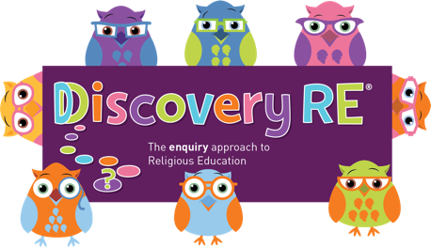
Discovery RE Knowledge Organiser
This knowledge organiser is a guide, offering key information to point the teacher in the right direction as to the beliefs underpinning the particular enquiry.
The summaries must not be taken as the beliefs of ALL members of the particular religion.

Religion /Worldview: Christianity | Enquiry Question: Why do Christians believe God gave Jesus to the world? | Age: 6/7 Year Group: 2 Autumn 2
This enquiry investigates the Christian belief in Jesus as a gift of love to humanity.

Core Knowledge (see also background information documents) |  | Link to other aspects of belief | Personal connection / resonance
Trinity: complete relationship between God (the Father), Jesus (his son) and the Holy Spirit. The three are “consubstantial”, which means that they exist separately and together as one  God became incarnate at Christmas and bought God’s love for the world to earth in human form.  This enquiry also reflects the concept of salvation: Christians believe that God gave the gift of his son to humanity in order to save them from sin and open up a pathway back to God through the death and resurrection of Jesus  Agape: Agape is universal love, such as the love for strangers, nature, or God. It is also called charity |  | God chose a Jewish young woman called Mary, who was engaged to Joseph the carpenter, to be the mother of his earthly son and sent his angel, Gabriel, to ask this of her. Mary agreed to allow this to happen and Jesus was born in Bethlehem  Easter/salvation – Jesus came to save humanity. | - Do I understand how a person can be or bring a “gift” into my life that is not material (e.g. love)?  - Can I understand the concept of agape? Is it something I want to foster in my own life? What would be the impact if I did?
Key Terms and Definitions | History/Context | Impact on believer/daily life | Spiral curriculum link
Agape: Agape is universal love, such as the love for strangers, nature, or God. It is also called charity  Trinity: God (the Father), Jesus (his son) and the Holy Spirit  Incarnation: God becoming man or literally being “made flesh”. | The birth of Jesus was not how the Jews traditionally thought the Messiah would come and lead them. Because of the Roman occupation, they hoped a Messiah would be an earthly king who would free them. | Christians believe God sent his son as a very different type of King to that which the Jewish people were expecting. They believe Jesus bought love which can be called agape. Agape can be defined as unselfish concern for the welfare of others. It incites a Christian to love their neighbour as themselves. | Builds on Year 1 Autumn 2 Christmas enquiry and Year 2 Autumn 1 reference loving your neighbour as yourself.  Year 6 Spring 1 builds on this teaching of Agape
Home learning ideas/questions:
Do we understand or can we explain to people at home the meaning of agape? How could we show that kind of love to the world? What would be the impact if everyone did this?

© 2020 Discovery RE Ltd

