Pick ‘n’ Mix Home Learning
Daily Treats  Homework to be completed daily. | Weekly Treats  Choose 4 pieces or more, to be completed by Wednesday 14th December  You can hand your work in at any time before this date. Remember to upload to Google Classroom too.
Home Reading  Read 4x per week at home. Record your reading in your reading diary and ask an adult to sign your book too. | Task 1 - Terrific Timelines  Make your own timeline of Ancient Greece showing the significant dates and what happened on them.  You might like to consider the following:  -When the Ancient Greek civilisation began  -The different periods of Ancient Greece  -First Olympics  -First marathon  Helpful website: https://www.ducksters.com/history/ancient_greek_timeline.php | Task 3 – A Groovy Greek Christmas  Find out how the Ancient  Greeks celebrated  Christmas. What did  Christmas mean to them?  Did they have a tree?  What did they eat? Did  they exchange gifts? | Task 5- Healthy minds  Following on from Black history month, we would like to think about someone who inspires you. By reflecting on the qualities and achievements of those we are inspired by we want to support children in recognising their own strengths and hopes for the future.  Create a portrait of the person, within it include the words, colours and symbols that represent that person. The link below from Place2Be gives more details on this art project.  https://www.place2be.org.uk/media/8d9873e4160225b/who-inspires-you-activity-from-place2be-s-art-room.pdf
Practice your times tables on TT Rock Stars  Complete 10 sessions of TTRS each week.  You could even do more. | Task 2 – Super Spartans  Spartan Training:  Research spartan training  and write a diary ‘A day  in the life of a Spartan  Soldier’ | Task 4 – I spy with my little eye…  Look at Bruegel’s picture The Fall of Icarus. Can you find him? Create your own version of this picture.  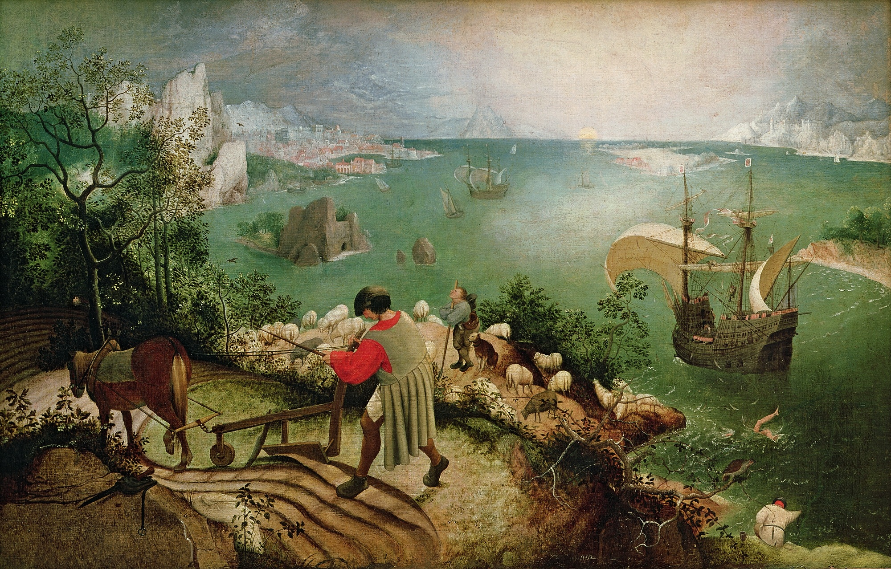 | Task 6 – RE  You have been learning all about Joseph. As a family, read or watch the story of Joseph. Joseph and his brothers - beginner’s bible: https://www.youtube.com/watch?v=Jy1DpebexTQ or  Part 1: https://www.youtube.com/watch?v=8g64jRGLgIw  Part 2: https://www.youtube.com/watch?v=qDKzxuk7zI0  Discuss what lessons Joseph might have learnt and what you can also learn from this story. Can you retell the story of Joseph in a creative way? You could do this through drama, use of your toys, create a comic strip, writing, pictures, collage, create an iMovie, PPT the choice is yours.

