 | Autumn | Spring | Summer
Educational visits / visitors to the school | Audiologist visitor  Church visit – Harvest and Christmas | Atomic Science visitor - Digestion  Church visit – Easter  Scientist visit – Science Week | Earth Trust Education Visit
Curriculum Experiences (500 things to do before you are 11 ¾) | Have fun with sticks  Go on a wintry adventure | Create some wild art  Make friends with a bug | Den building  Roll down a really big hill  Eat a picnic in the wild (Forest School site)
Exceptional learning experiences | Wow day – scientists  Forest School  Children In Need  Christmas Jumper Day | School choir  Three Faith Tour  Children’s Mental Health Week  World Book Day  Science Week | Stone Age Day  Stone Age Assembly/Play  Bikeability Award  Sports Day
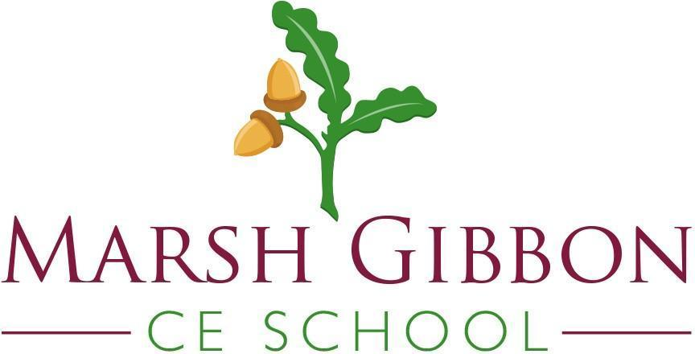
Succeeding together - fostering a love of learning, within a nurturing Christian community, to bring out ‘the best in everyone’.
How can I say “I can’t’ when the Bible says: I can do everything through Him who gives me strength.’ Philippians 4:13
Year Three- Cultural Capital and Personal Development

Place of worship – Church, Gurdwara, Mosque

