Daily Treats  Homework to be completed daily. | Weekly Treats  Choose 4 pieces or more, to be completed by Wednesday 15th February 2023.  You can hand your work in at any time before this date. Remember to upload to Google Classroom too.
Home Reading  Read 4x per week at home. Record your reading in your reading diary and ask an adult to sign your book too.  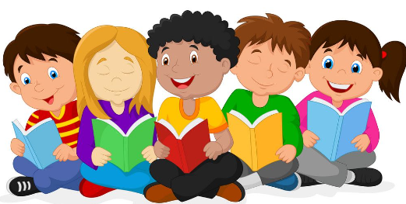 | Task 1 –Science  What’s your favourite animal (excluding your pets)? Research how an animal has adapted to their habitat. What characteristics does it have to help it survive? Some good ones to look at are camels, penguins and giraffes. You could even look at how different species of the same animal differ in their adaptations. E.g. foxes and bears.  How can you creatively present what you have found? | Task 3 - English  Research your family tree.  Create a scrap book with photos to show how members of your family are similar in looks and personality.  Include a cover, a contents page and don’t forget to include interesting or unusual facts about your family. | Task 5 – Healthy Minds  Place2Be Exploring emotions through colours  This project offers the opportunity to explore colour in relation to our experiences. We can use colour to help us make sense of how we are feeling, who we are and the world we live in.  Visit the link below to find 3 activities  (The colours in me. My colours, World of colour)  Choose 1 or try all 3!  https://www.place2be.org.uk/media/4vkbp5ek/the-art-room-at-home-colours.pdf
Practice your times tables on TT Rock Stars  Complete 10 sessions of TTRS each week.  Can you do more? | Task 2 – DT  Humans of the future  Research how humans have evolved. How do you think we will evolve over generations to come? Design your idea of a future human – draw and label them; you could even create a model!  Consider what the future may hold and what adaptations the human race would need to evolve in order to survive. | Task 4 – Art  Make your own jelly fossils.  Use this video and resource: https://www.stem.org.uk/resources/ elibrary/resource/36611/fossils  to understand what fossils are and how they are created.  Then have a go at making your own! | Task 6 – RE  Jesus chose ordinary people like the fishermen Mark 1.16-20 Luke 5.1-11 and  the tax collector Luke  19:1-10 to be his friends.  I wonder what we can  learn about friendship from these stories?  Read/research both of these stories  and then write your own explanations of what we can all learn about friendship from  them both.

