Religious Education: | Year 1 |  | Summer 2 |  | Enquiry Question: Are Rosh Hashanah and Yom Kippur important to Jewish children? |  |  |  |  | Religion: Judaism
In this enquiry, you will look at how Jews try to solve any problems that have arisen in the previous year. You will reflect on what they might like to solve in the recent past.
What we will learn: |  |  |  |  |  |  | Links to other aspects of belief |  | Personal connection
- Rosh Hashanah is the Jewish New Year.  - Rosh Hashanah commemorates the anniversary of creation – the birth of the Universe.  - It is the day of judgement and the day of remembrance for rabbis (Jewish teachers).  - It is a day of prayer, a time to ask for help in the year ahead and to remember the power of God.  - Yom Kippur is the day of Atonement.  - Yom Kipper is 10 days after Rosh Hashanah.  - Yom Kippur remembers the day Moses asked God to forgive the people of Israel for their sins.  - Yom Kippur is the holiest day of the year for Jewish people. |  |  |  |  |  |  | - Personal prayer – reflection  - Reading the holy books and remembering the examples and teaching of the prophets  - Joining together as a community of believers |  | - Why is it a good idea to sort any arguments out?  - What would I like to put right?  - Is it a good idea to have a fixed date to remember to sort out arguments?  - What impact would this have on my life if I acted in this way?
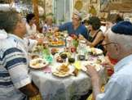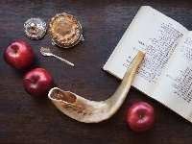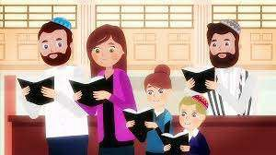
Key Vocabulary |  |  |  |  |  |  |  | Impact on believer/daily life
Rosh Hashanah: Jewish New Year |  |  |  | Shofar: ram’s horn |  | 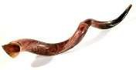 |  | - Knowing that a specific date comes round to reflect on and solve issues could help Jews to not bear grudges.  - Reflecting on poor behaviour can sometimes be difficult.
Yom Kippur: The Day of Atonement – the holiest day for Jewish people |  | 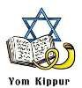 |  | Challah bread: special bread used at this time
Home learning ideas/discussions:
Why is it good to reflect on the highs and lows in our lives? Do we need to take any actions to fix any small arguments or disagreements we might have had with someone?

