Religious Education: | Year 1 |  | Summer 1 |  | Enquiry Question: Is Shabbat important to Jewish children? |  |  |  |  | Religion: Judaism
In this enquiry, you will learn about the Jewish Creation Story and the way Shabbat is commemorated. You will learn why it might be important to give thanks and to share family time.
What we will learn: |  |  |  |  |  |  | Links to other aspects of belief |  | Personal connection
- Shabbat is the day of rest in the Jewish religion.  - The Jewish Holy books (Tanakh) contain core beliefs and stories including the Creation Story.  - Jewish people believe God created the work in six days and rested on the 7th day, the day of rest –Sabbath.  - One of the 10 commandments is to ‘Honour the Sabbath’.  - Shabbat (Sabbath) is celebrated both in the home and the synagogue.  - The start of Shabbat is marked with a special meal and ceremony at home.  - When worshipping, a skull cap called a kippah is worn, usually by males, as a sign of respect to God. |  |  |  |  |  |  | - It is similar to the Creation Story found in the Bible.  - The different Jewish responses to the day of rest and the definition of ‘work’  - Worship – How do Jews mark the Sabbath? |  | - Why might it be a good idea to have a day away from work?  - What other things could we think about on this day?  - What do Jews thank God for on this day?  - What do I have to be thankful for?
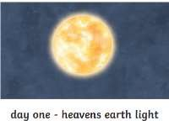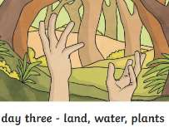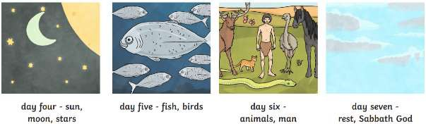
Key Vocabulary |  |  |  |  |  |  |  | Impact on believer/daily life
Shabbat: Sabbath – A day of rest |  |  |  | Tanakh: Jewish holy books, it is the Jewish bible |  | 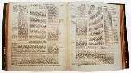 |  | - Preparing for the Sabbath is important to Jews  - No work should be attempted from sunset on Friday until sunset on Saturday.  - Food is prepared before the Sabbath starts and a family meal is often shared to commemorate the events.
Kippah: skull cap, a small piece of cloth covering the head, usually worn by Jewish males |  | 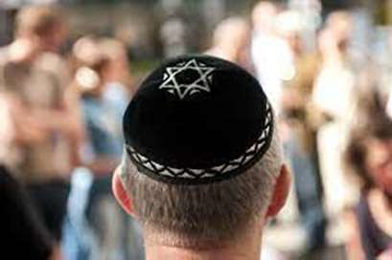 |  | Challah: a special bread of Ashkenazi Jewish origin, usually braided and typically eaten on ceremonial occasions such as Shabbat and major Jewish holidays. |  | 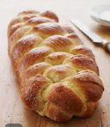
Home learning ideas/discussions:
Is it easy to have family time? What could the whole family do together? Do we have a set time we are together every week? How special are the activities we do? If we don’t, is this something we would like to introduce? Why?

