Religious Education: | Year 1 | Spring 2 | Enquiry Question: What happened when Jesus went into Jerusalem? |  |  |  |  |  | Religion: Christianity
The enquiry looks at the events of Palm Sunday and their significance to Christians today.
What we will learn: |  |  |  |  | Links to other aspects of belief |  |  | Personal connection
- The events of Holy Week beginning with Palm Sunday.  - Palm Sunday is when Jesus rode into Jerusalem.  - Christians believe that Jesus died on the cross to save people from the wrongs they had done. This is called ‘Salvation’.  - Jesus had a special meal with his disciples (friends) called ‘The Last Supper’.  - During the ‘Last Supper’, Jesus shared wine and bread and this is recreated during Holy Communion in churches today. |  |  |  |  |  | - Christians believe that Jesus is the Son of God.  - He was put to death on Good Friday.  - He rose from the dead on Easter Sunday.  - He died to save people from their wrong-doings, ‘sins’  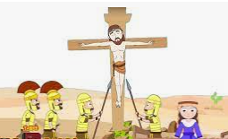 |  | - What do I feel about the way Jesus was treated?  - Is there anybody special that I would be really excited to see, that I would line the streets for and cheer for?  - What events in my life will I need to plan for?  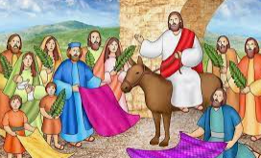
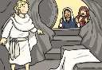
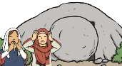
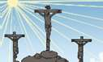
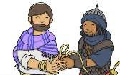
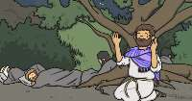
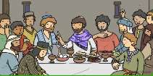
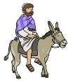
Key Vocabulary |  |  |  |  |  |  |  | Impact on believer/daily life
salvation: the saving of a person from sin or wrong-doings |  |  | 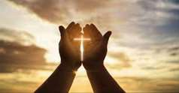 | resurrection: rising from the dead |  |  | 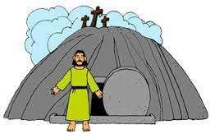 | - Because Jesus was treated as a king by lots of people, Christians can think of Jesus as a very special person, like royalty.  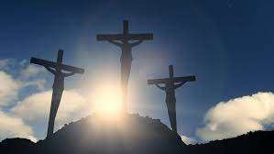  - Christians believe in life after death because Jesus rode from the dead.
crucifixion: leaving someone to die on a cross |  |  | 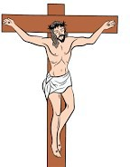 | disciples: Jesus’ special friends |  |  | 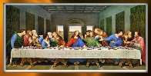
Palm Sunday: the event in the Bible (The New Testament) of Jesus entering into Jerusalem and being greeted by the people waving palm branches. |  |  | 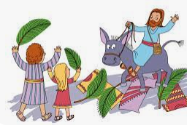 | Palm Cross: is made from a palm leaf. The Palm Cross is used for Palm Sunday celebrations before Easter to remember Jesus' entry into Jerusalem just a few days before His Crucifixion. |  |  | 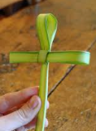
Home learning ideas/discussions:
What events in our life do we need to prepare for? What steps would you take to succeed in your goal?

