Religious Education: | Year 1 |  | Spring 1 |  |  | Enquiry Question: Was it always easy for Jesus to show friendship? |  |  |  |  | Religion: Christianity
The enquiry is focussed on the Christian belief in the Incarnation and the relationship that Jesus, who Christians believe is God’s son, had with the people around him.
What we will learn: |  |  |  |  |  |  | Links to other aspects of belief |  |  | Personal connection
- The Christian concept of incarnation: God becoming man or literally being ‘made flesh’.  - That Christians believe Jesus was fully human and fully God, and was unable to do any wrong.  - Jesus made friends with outcasts and law-breakers.  - How Jesus showed friendship to others.  - The story of Zacchaeus from the Bible. |  |  |  |  |  |  | - Jesus was both divine and human and became man.  - Jesus lived amongst everyday people.  - Jesus believed in forgiveness.  - In the Bible, Jesus makes it clear that people need to forgive each other for any wrong doing. |  |  | - What do I feel about the types of people Jesus befriended?  - Could I think of a situation where I might find it difficult to be a friend and how I might overcome this?  - What do I think about Jesus’ example of Christians?
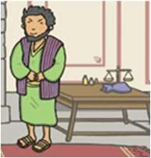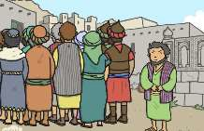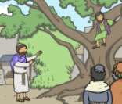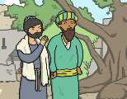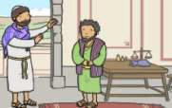
Key Vocabulary |  |  |  |  |  |  |  |  |  | Impact on believer/daily life
Incarnation: God becoming man or literally being ‘made flesh’ |  | 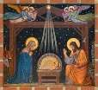 |  | Zacchaeus: a dishonest tax collector in the bible and a man that people did not like |  |  |  |  | 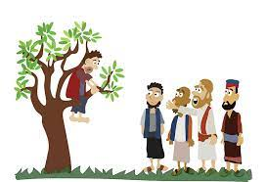 | - Jesus was disliked for being friends with unpopular people.  - Christians today have to decide whether the can or want to follow Jesus’ example of being a friend (or neighbour) to everyone.  - Christians should be a good friend to everyone even when they think that person might not deserve friendship.
Forgiveness: letting go of unkind thoughts or feelings about someone, accepting their pology |  |  |  | Mary and Martha: Mary and Martha, who are sisters, open their home to Jesus as he travels with his disciples. As Martha hurries to ensure the preparations, Mary simply sits at the feet of Jesus and listens to him. |  |  |  |  | 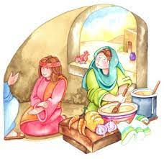
Acceptance: taking something someone has given to you, such as an apology |  |  |  |  | Disciples: Jesus’ special friends  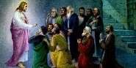 |  |  | Lazarus: a man who Jesus bought back to life  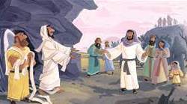
Home learning ideas/discussions:
Who might we help or be friendly towards who the world do not treat very well (e.g. homeless people)?
What could we do to show friendship to people that we wither don’t know very well or whom we are not naturally drawn to be friendly towards?

