Religious Education: | Year 1 | Autumn 2 | Enquiry Question: What gifts might Christians in my village have given Jesus if he had been born here rather than in Bethlehem? |  |  |  |  | Religion: Christianity
This enquiry is focussed on the first Christmas and more specifically the gifts that Jesus received, their meaning and symbolism and how that compares with gifts today.
What we will learn: |  |  |  |  | Links to other aspects of belief |  | Personal connection
- Mary was chosen by God to be the mother of Jesus.  - Mary was tod of God’s news by the angel Gabriel.  - Jesus was born in Bethlehem.  - The star in the sky symbolises Jesus’ importance and how he could be a light for other nations.  - The gifts show that Jesus was a type of both king and God, and would die. |  |  |  |  | - Christians believe in the Trinity. This is the complete relationship between God (the Father), Jesus (his son) and the Holy Spirit.  - Christians believe that Jesus is the Son of God.  - Jews at the time were awaiting their Messiah.  - They did not believe the saviour would be an earthly king. . |  | - What do I feel about the gifts Jesus was given? Are they the sorts of gifts I would give a baby today?  - What gifts can I consider which may have a deeper symbolism or meaning which is relevant to life today?  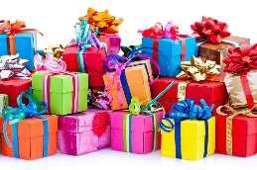
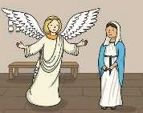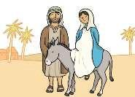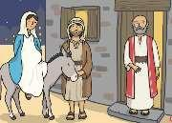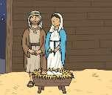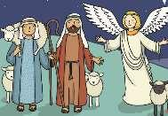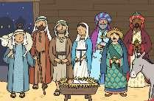
Key Vocabulary |  |  |  |  |  |  | Impact on believer/daily life
Magi / Wise men: visitors from the East who travelled to find a king because they had seen a star. |  |  | 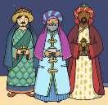 | Frankincense: (an incense) is a symbol of deity. |  |  | Jesus was different to earthly kings.  Jesus was a king to all people.  Christians believe Jesus is a gift from God.  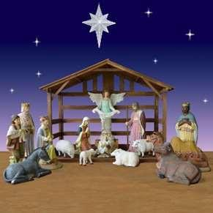
Gold: symbolises kingship on earth |  |  | 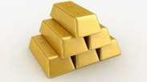 | Myrrh: (an embalming oil) is a symbol of death. |  | 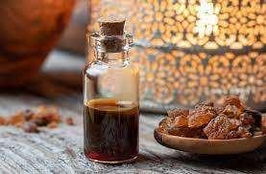
Home learning ideas/discussions:
If we celebrate Christmas, what gifts do we like to give and receive? Have we ever received anything which had a lot of significance?
If we don’t celebrate Christmas, do we ever give gifts to each other and what significance might they have?

