Religious Education: | Year 1 | Autumn 1 | Enquiry Question: Does God want Christians to look after the world? |  |  |  |  |  | Religion: Christianity
In this enquiry, you will focus on the Christian story of Creation and the responsibility a Christian might feel for caring for the world
What we will learn: |  |  |  |  |  | Links to other aspects of belief |  | Personal connection
- The Story of Creation from the bible.  - That according to the Bible, God is the creator of the world.  - God gives the first humans the responsibility to look after the world He has created. |  |  |  |  |  | - Christians believe in the Trinity. This is the complete relationship between God (the Father), Jesus (his son) and the Holy Spirit.  - God “the Father” was the Creator as the Bible tells Christians that it was He who spoke the words of creation. |  | - Do I feel it is important to look after the world?  - Why?  - What happens if we don’t care about it?  - What do I believe about creation?  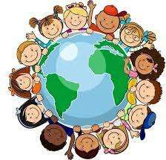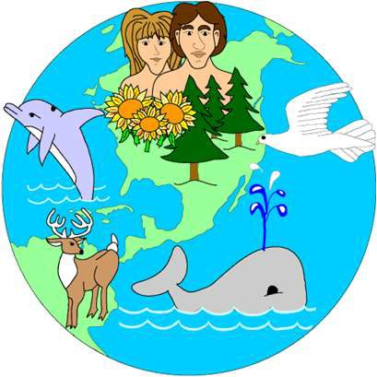
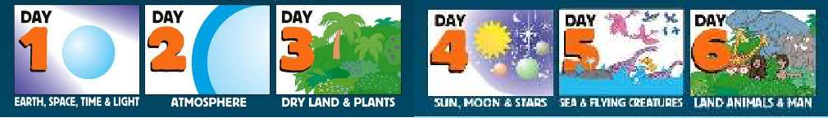
Key Vocabulary |  |  |  |  |  |  |  | Impact on believer/daily life
Bible: Christian Holy Book |  |  |  | 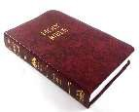 | Creation: the making of the world by God |  |  | Christians believe that they should look after God’s creation and that if they neglect, abuse and spoil the environment, they are damaging something that is precious to God.
Old Testament: the part of the bible which explains God’s relationship with his people before Jesus, who Christians believe is the Song of God, came to earth |  |  |  | 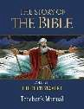 | Adam: The first man that Christians believe God created |  | 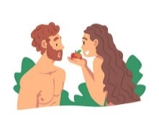
Genesis: First book of the Bible |  |  |  | 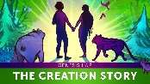 | Eve: The first woman that Christians believe God created
Home learning ideas/discussions:
What do we do at home to help look after the world? Why do we do this? Do we have any beliefs about creation?

