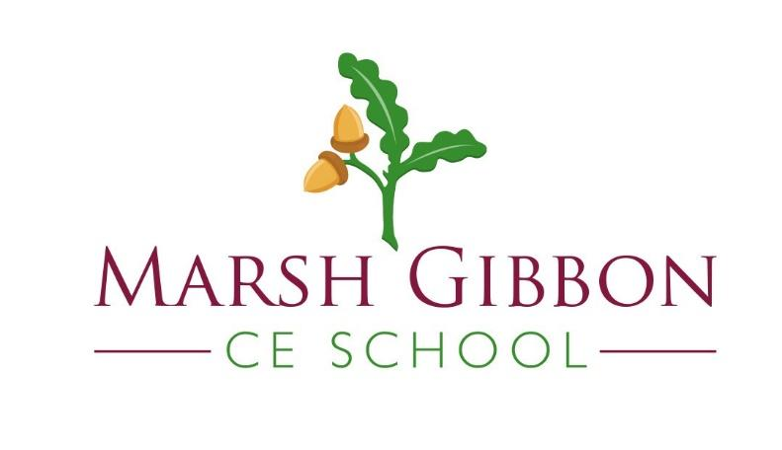

Pick ‘n’ Mix Home Learning
Daily Treats  Homework to be completed daily. | Weekly Treats  Choose 4 pieces or more, to be completed by Wednesday 18th October  You can hand your work in at any time before this date. Remember to upload to Google Classroom if it is not something you can bring into school. .
Home Reading  Read 4x per week at home. Record your reading in your reading diary and ask an adult to sign your book too.  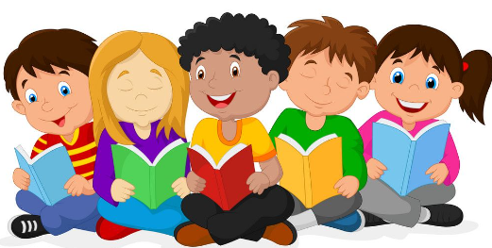 | Task 1 - Design a Book Cover  Design your own book cover for One Day On Our Blue Planet In The Savannah by Ella Bailey  Remember to make the illustrations stand out and the author’s name should be on the front, too. You are trying to persuade someone to pick up the text to read it. What colours will you use? How will your book cover stand out from the others on the shelf? | Task 3 - Seasonal Changes  What happens when the seasons change? How many seasons are there? What can you see, hear, smell?  Create a piece of work to show each of the seasons and what they look like. You could make a poster with images and labels, or write about each season. Be as creative as you like! | Task 5- PSHE -Being me in my world  We are all special. We are all unique. What do you like/dislike? What do you want to be when you grow up? What difference will you make to the world? What are your values? What would you like to achieve this school year?  Let your teacher really get to know you by creating a ‘Guide to Me’. This could be a poster, a fact file, a booklet, a presentation, anything goes, the more creative the better.
 | Task 2 – Food From Around The World  Choose a food from a different country and have a go at making it. Make sure you take a picture of your final product! You may want to write out the recipe to share with your friends. | Task 4 – New World  If you were to create your own world how would you describe it? What would be included in your world? What would make it different to the world we live in today?  Your task is to write a description of your new world. You might like to draw a picture of it, too. | Task 6 – School Safety  Marsh Gibbon is a safe school for everyone. Everyone at school is here to keep you safe. Please produce a poster or information sheet to show how you are kept safe by everyone at school. You can use colouring pencils, pens or create this on the computer. Please put your name on this and your year group as they will be displayed at school.  