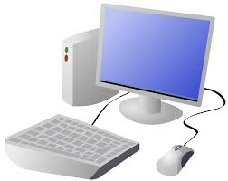
COMPUTING: CREATING MEDIA- 3D Modelling
KNOWLEDGE ORGANISER
Y6

Overview |  |  | More Advanced Techniques
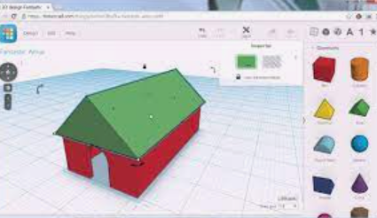  3D Modelling  -3D means three-dimensional, or having 3 dimensions. For example, a box is a 3D shape, whereas a square is a 2D shape.  -3D modelling involves using computer software to create 3D shapes, in order to produce models of real-world objects.  -3D modelling allows us to view designs from different angles and experiment with various designs.  -3D modelling is used in many industries, e.g. in interior design, architecture and making video games.  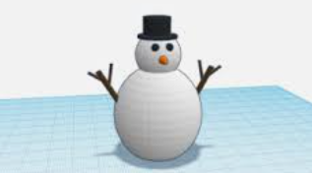 |  |  | Duplicating: Click and drag around an object to ensure that it is selected. Then, click on the duplicate icon (see left) to create a copy.
 |  |  | 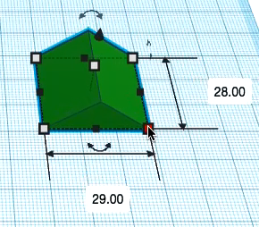  Resizing: Objects can be manually resized by clicking and dragging on the handles around them. The dimensions are labelled. | 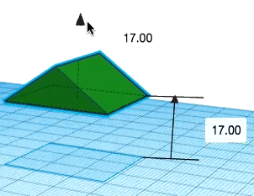  Lifting: Use the ViewCube to change the viewing angle of the model to the front/ side. Then, use the cone handle in order to lift the object from the workspace.  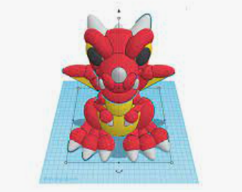  Combining Shapes Many complex shapes are made up of a number of 3D shapes – we can position and merge them together.
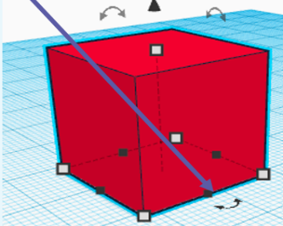
Rotating: Selecting these handles allows us to rotate shapes. Drag the object to rotate it in different ways.

Text: You can add block text by selecting ‘text’ in the shapes. This can help you to enhance other shapes.
The Basics of 3D Modelling |  |  | 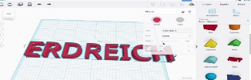
‘Tinkercad’ is one example of software that we can use to create 3D Models. Other examples include ‘CAD for Kids’ and ‘Sketchup 3D.’
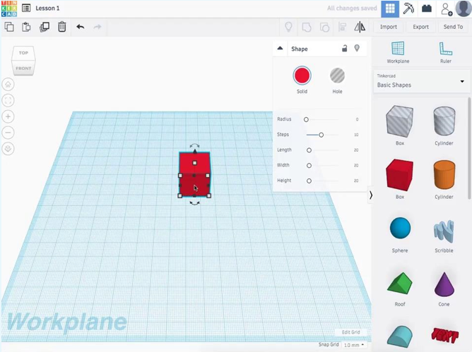  -The ViewCube Allows us to switch the view of the model e.g. from the front angle, top angle, or spin around to show the sides.  -Change the colour/ shading of your model, and make them solid or ‘hole.’  -Zoom in and zoom out.  -The workspace, where you can work on your model. The square panes help us to distances and dimensions accurately.  -Alter the dimensions of your model, for example the length, height, width and shape.  -Objects can be resized by dragging the handles (white squares).  -When you move multiple objects into the same space, they merge. |  |  | Making Holes
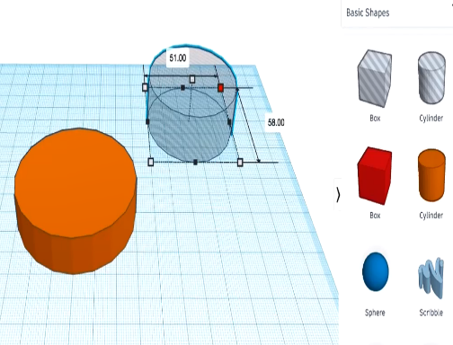
Holes: Sometimes we need to create objects that are not solid – they have space inside/ within them.
-To achieve this, begin by adding a 3D shape onto the workspace. Then drag one of the ‘holes’ shapes onto the workspace. Adjust dimensions accordingly.
-Drag the ‘holes’ shape over the 3D shape as desired.
-Click and drag a box around the shapes to select them.
-Click the ‘group’ button to combine the shapes and create the hole.

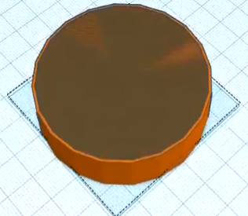

 |  | -3D objects that can be dragged into the workspace and remodelled.

Important Vocabulary
Modelling Three-Dimensional Workspace Faces Vertices Edges Handles Resize Position Hole Design Modify

