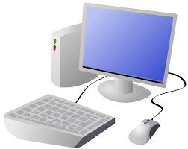
COMPUTING: PROGRAMMING- Selection in Quizzes
KNOWLEDGE ORGANISER
Y5

Overview |  |  | Selections and Conditions
Quizzes in Scratch  - Programming is when we make a set of instructions for computers to follow.  -Scratch is a program that we can use in order to code our own quizzes, stories, animations and games. We can input questions using the ‘ask’ command blocks. We can use selections and conditions in order to ensure that there are different outcomes depending upon a user’s response.  -We use algorithms (a set of instructions to perform a task) to sequence movements, actions and sounds in order to program effective animations.  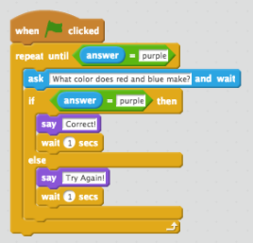  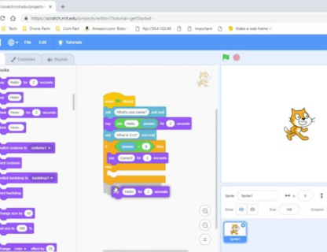 |  |  | 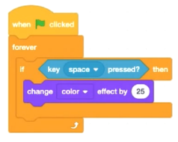  -Creating Conditions: The ‘If-then’ command block helps us to create conditions. It is one of the darker orange control blocks. Other blocks are placed inside the ‘If-then’ blocks to create conditions.  The ‘senses’ blocks (light blue) create the ‘trigger’ (e.g. when a certain key is pressed). We can change the trigger by pressing the downward arrow and selecting from the range of keys/ actions. The ‘actions’ blocks (e.g. motions, sounds, etc). are then used to program what will happen when the ‘senses’ command is triggered.  -Different Outcomes: The ‘If-then-else’ command block helps us to write programs that have selections with two outcomes.  -Actions to be carried out if the condition is ‘true’ (if the conditions of the ‘sense’ command are met) are placed below ‘then.’ Actions to be carried out if the condition is ‘false’ (e.g. if any other key is pressed) go below ‘else.’  -The ‘forever’ block means that the command will happen continually.  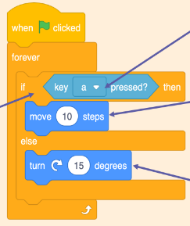  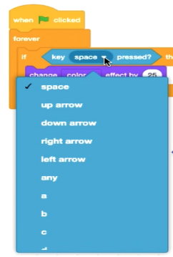
The Basics of Scratch
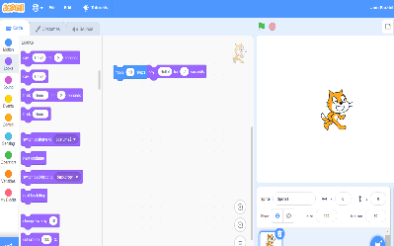
-What is Scratch? Scratch is a website/ app that lets us code our own quizzes, stories, games and animations.

-Scratch helps us to learn how to use programming language, whilst also being creative and using problem-solving skills.
 |  |  | Asking Questions | Algorithms, Trialling, Debugging
 |  |  | 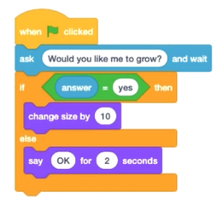  -Questions can be included by using the ‘ask’ command blocks.  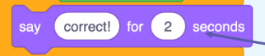  -If specific answers are needed (e.g. yes or no), these can be typed in when using the ‘answer’ sensing block within the = ‘Operators’ block - drag it into the first white space. In the second white space, we can then type in the desired answer.  -The ‘say’ command block (in looks) is used to inform the user if the response was correct. | -Designing an algorithm (set of instructions for performing a task) will help you to program the sequence that you require.  -Programmers do not put their computer programs straight to work. They trial them first to find any errors:  -Sequence errors: An instruction in the sequence is wrong or in the wrong place.  -Keying errors: Typing in the wrong code.  -Logical errors: Mistakes in plan/thinking.  -If your algorithm does not work correctly the first time, remember to debug it.
There are three main areas in Scratch:  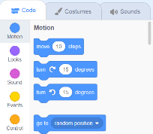  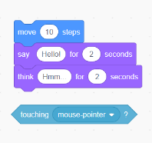  -The Blocks Palette (on the left) contain all of the different blocks: puzzle piece commands which control the animation.  -Code Area (in the middle) is where the blocks are placed to create a program.  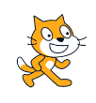  -Stage with Sprite (right) is where the output of the program is presented. The sprite is the character. | Attributes: There are three attributes of the sprite which we can change to make our animation: Code, Costumes, Sounds.  -Event Blocks: Event blocks are coloured yellow and are used to sense different events that happen e.g., the green flag being clicked.  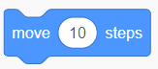  -Action Blocks: Action blocks include ‘Motion’ blocks, ‘Sound’ blocks and ‘Looks’ blocks. They make the sprite move, make sounds and change appearance.
Important Vocabulary

Selection Condition True False Count-Controlled Loop Outcomes Conditional Statement

