COMPUTING: CREATING MEDIA- Vector Drawing
KNOWLEDGE ORGANISER
Y5

Overview |  |  |  | More Complex Vector Drawings
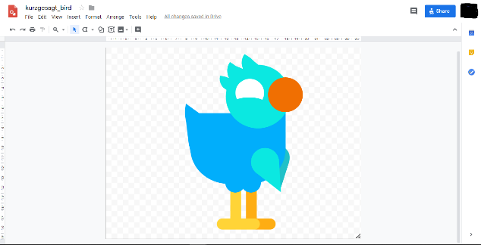  Vector Drawing  -Vector drawings are computer graphic images that are made using 2-D shapes.  -The drawings are connected by lines and curves to form polygons and other shapes, forming a complete picture.  -There are lots of different apps and programs that can help us to complete vector drawings, including Google Drawings and Adobe Illustrator.  -Many techniques, e.g. zooming, rotating, resizing & duplicating, can help to create accurate images.  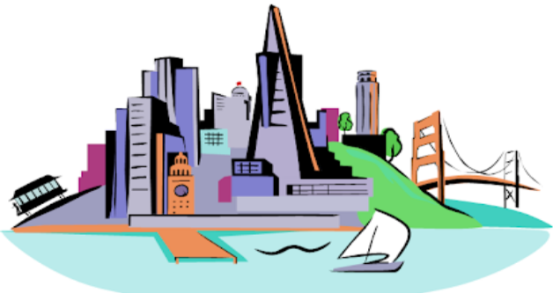 |  |  |  | Google Drawings has been used in these examples, but lots of other vector drawing software uses the same tools and functions.
 |  |  |  | When dealing with small and intricate objects, it is important to use the zoom tool. Zooming in allows you to work with more precision. Zooming out allows a wider view. | The line tools can be used to help you change the colour and weight (thickness) of the line, and to make dotted lines.  Coloured lines can be drawn, and colours can be used to fill shapes.  Gradient colours can be used to colour the same object in different colours.  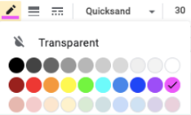  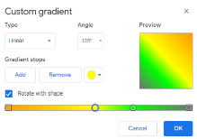
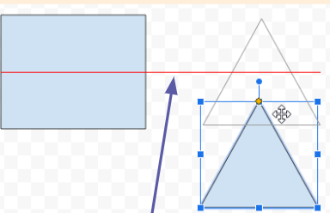
The Alignment guides pop up as you move objects around, and help you to align and size objects.

Creating Simple Vector Drawings |  |  |  | 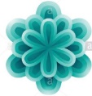  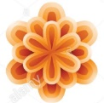  Remember to that vector drawing is all about layering. By gradually adding layers of basic shapes, you build up something far more complex.
Vector drawings use lines and shapes to create bigger and more detailed images.
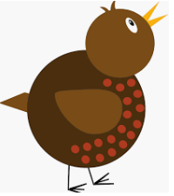  Plan your drawing by thinking about what shapes it is made up of. Each shape is called an object.  Circles | The tail is furthest away so is drawn first.  When vector drawing, the shapes overlap, so start with the objects that are the furthest away. |  |  | Advanced Tips
 |  |  |  | 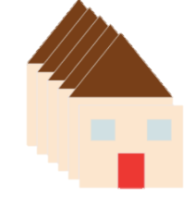  Grouping: 1. Select all images. 2. Right-click 3. Choose ‘group.’ All of the objects can now be moved and changed at the same time. |  | Selecting Multiple Objects  This allows you to perform tasks with the whole drawing, rather than individual objects:  -Click, drag and drop a box around all of the objects in an image. This allows you to select all of the objects.  -When you perform an action (e.g. copy and paste) it will now apply to all.
Copy and paste has been used to make the red spots the same size.  You can save a lot of time and effort doing the same thing over and over by duplicating shapes. This is done most easily by copying the object that you want to duplicate (hold ctrl + c) and pasting (hold ctrl + v) a new one. |  |  |  | Backgrounds: You can create backgrounds by uploading images (using this icon). Remember to ‘send to back’ after it has been inserted.  Advanced Layering: Right-click on objects and use the ‘send to back’ and ‘bring to front’ tools (in ‘order’) to ensure that your layering is in the correct order.
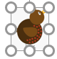  You can enlarge/reduce an object by clicking on it and dragging the handles to the desired size. | 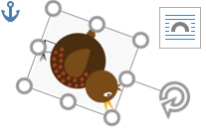  You can rotate an object by dragging the circular handle at the top.

Important Vocabulary
Vector Drawing Tools Icons Toolbar Vector Drawing Move Resize Rotate Duplicate/Copy Organise Zoom Select Alignment Grid Handles Consistency Modify Layers Object Paste Group Ungroup Reuse Improvement Alternatives

