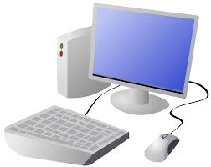
COMPUTING: PROGRAMMING- Repetition in Games
KNOWLEDGE ORGANISER
Y4

Overview |  |  | Loops and Repetition
Repetition in Scratch  - Programming is when we make a set of instructions for computers to follow.  -Scratch is a program that we can use in order to code our own stories, animations and games. We can use repeat and loop operator blocks in order to make our programs more logical and efficient. These help to run code continuously or for a set number of times.  -We use algorithms (a set of instructions to perform a task) to sequence movements, actions and sounds in order to program effective animations.  - In day-to-day life, we use many patterns of repetition. This may include things like; brushing your teeth, performing a dance routine, creating a piece of music, finding a clapping rhythm.  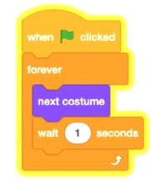  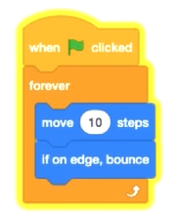  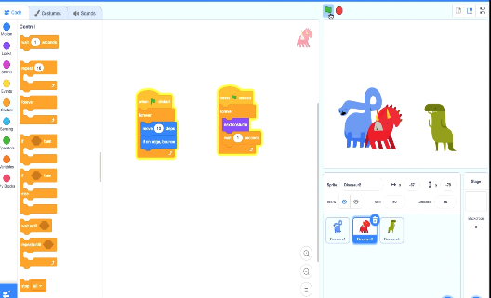 |  |  | 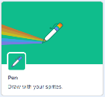  -Pen Drawing in Scratch: Select the ‘add extension’ icon in the bottom left corner. Then select ‘pen.’ This allows you to draw with your sprites.  -The Repeat Block: Select ‘code’ and then the ‘control’ blocks (orange). Here you will find the repeat block. It should be placed around the command blocks that you want to repeat. The number of times something is repeated can be typed into the white area.  -Creating Shapes: Selecting ‘pen down’ (in the ‘operators’ blocks) can be followed by use of the motion blocks to determine the line that will be drawn (e.g. ‘move 10 steps’). Turning a number of degrees changes the direction of the pen. Placing the repeat block around this motion code can allow more complex shapes to be drawn.  -Count-Controlled/Infinite Loops: We can control the number of ‘loops’ of a command with the number typed into the ‘repeat’ block. The ‘forever’ block makes a command continue infinitely (forever).  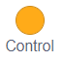  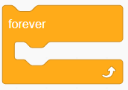  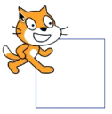  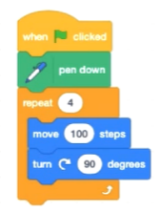  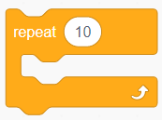
The Basics of Scratch
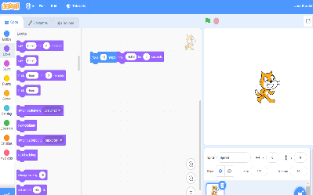
-What is Scratch? Scratch is a website/ app that lets us code our own stories, games and animations.

-Scratch helps us to learn how to use programming language, whilst also being creative and using problem-solving skills.
 |  |  | Event Managing and Efficiency | Algorithms, Trialling, Debugging
 |  |  | 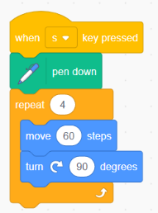  -We should ensure that programs are coded and labelled in easy-to-understand, user-friendly ways.  -Using the ‘events’ blocks logically can help to make your programming easy to use. E.g. when ‘s’ key pressed a square is drawn, when ‘h’ key is pressed a hexagon is drawn.  -Efficiency is about getting the right result in the easiest way possible, wasting little time or effort. Our use of the repeat and loop tools should help to create efficient programs. | -Designing an algorithm (set of instructions for performing a task) will help you to program the sequence that you require.  -Programmers do not put their computer programs straight to work. They trial them first to find any errors:  -Sequence errors: An instruction in the sequence is wrong or in the wrong place.  -Keying errors: Typing in the wrong code.  -Logical errors: Mistakes in plan/thinking.  -If your algorithm does not work correctly the first time, remember to debug it.
There are three main areas in Scratch:  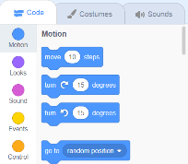  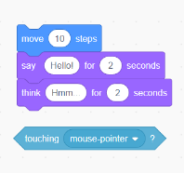  -The Blocks Palette (on the left) contain all of the different blocks: puzzle piece commands which control the animation.  -Code Area (in the middle) is where the blocks are placed to create a program.  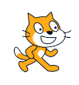  -Stage with Sprite (right) is where the output of the program is presented. The sprite is the character. | Attributes: There are three attributes of the sprite which we can change to make our animation: Code, Costumes, Sounds.  -Event Blocks: Event blocks are coloured yellow and are used to sense different events that happen e.g., the green flag being clicked.  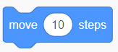  -Action Blocks: Action blocks include ‘Motion’ blocks, ‘Sound’ blocks and ‘Looks’ blocks. They make the sprite move, make sounds and change appearance.
Important Vocabulary
Loop Repeat Value Forever Count-controlled loop Animate Event block Duplicate Modify Refine

