COMPUTING: CREATING MEDIA- Photo Editing
KNOWLEDGE ORGANISER
Y4

Overview |  |  |  | Using Software
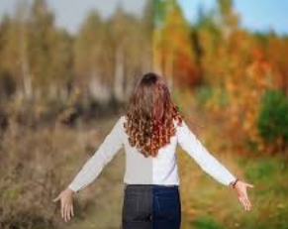  Photo Editing  -You should already know that we can use digital devices to help us to take and edit photographs.  -There are many different apps and programs to edit and improve photos, for example Photoshop, Luminar and paint.net  -There are lots of different ways that we can edit photographs, for example cropping, rotating, flipping, and changing colours and styles.  -We should understand the not all photographs that we see are real – they may have been edited.  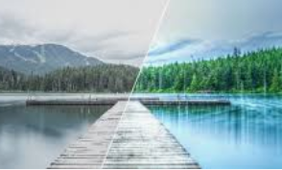 |  |  |  | Paint.net is one example of photo editing tool, but many others are available. Below is how to select, copy and paste in new elements to edit your photograph.
 |  |  |  |  | 3.Open the image that you want your copied photo in. Select ‘paste.’  1.Open the photo and use the ‘lasso select’ tool to select the area that you need. | 4.Use the handles to resize the image, and drag into position.  2.Right click on the image and select ‘copy.’ |  | 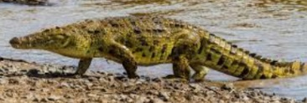
 |  |  |  | 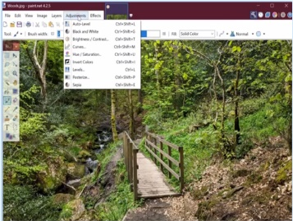  The ‘Adjustments’ tab allows us to turn the photo black and white, and change contrast & brightness. |  | The ‘clone stamp’ copies pixels from one part to another. ‘Recolor’ is used to replace colours. ‘Magic wand’ allows areas with a similar colour to be selected.
Editing Techniques |  |  |  | When we want to save our edit, we should click on this icon or the ‘save’ button. We can reverse the last thing we have done with the undo tool.
Below are a number of different ways that we can edit photographs.

When we only need a part of a photograph, we can crop the image. We can also enlarge and reduce the parts that we need.  Photograph editing programs often have filters. These can change the colours in a photograph. Different colours can give us different feelings. | 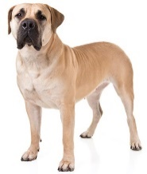  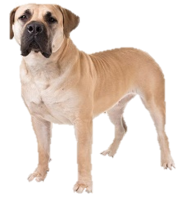 |  |  | Considerations of Edited Photos  Negative Reasons for Editing Photos  -To try to deceive people;  -To embarrass or put down others;  -To spread fake news or dishonest ideas.
 |  |  | We can make more than one of an image by copying it. We can also rotate and flip images to create different effects. | -As photographers and editors become more skillful, and editing programs become more advanced, it can be hard to tell if images are real or edited.  -We therefore need to be alert, and not believe everything we see. We should also edit photos for positive, and not negative reasons (see right). |  |  | Positive Reasons for Editing Photos  -To make things clearer;  -To highlight the important things;  -To show things in a nice way;  -To avoid embarrassment.
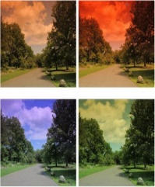 |  |  | When the lighting of the photograph is not quite right, we can change the brightness of the photograph.
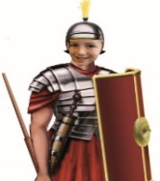  We can add and remove parts of a photograph by using cut, copy and paste tools. | 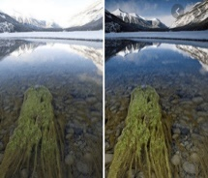  We can change the contrast of photographs, making the subjects clearer.
Important Vocabulary

Arrange Digital Crop Undo Copyright Composition Pixels Rotate Flip Effects Hue/Saturation Sepia Illustrator Vignette Retouch Clone Recolour Sharpen Brighten Composite Cut Copy Paste Original Border Layer

