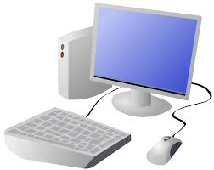
COMPUTING: PROGRAMMING- Sequence in Music
KNOWLEDGE ORGANISER
Y3

Overview |  |  | Programming Using Blocks
Sequencing in Scratch  - Programming is when we make a set of instructions for computers to follow.  -Scratch is a program that we can use in order to code our own stories and animations.  -We use algorithms (a set of instructions to perform a task) to sequence movements, actions and sounds in order to program effective animations.  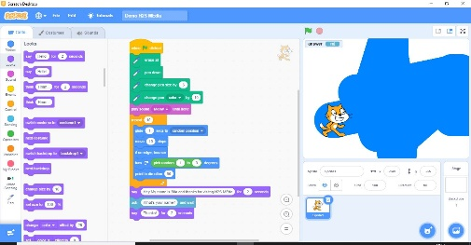  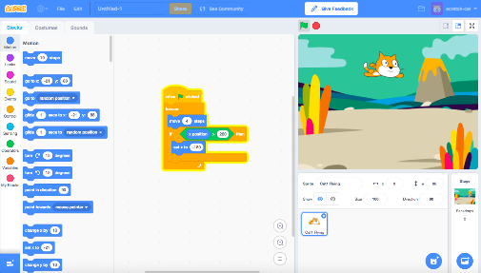 |  |  | -Basic Programming: Make sure that the feature of the stage that you want to program (e.g. sprite, background) is selected by clicking on it. Drag the block command that you want onto the code area. Blocks can be deleted by right-clicking on the block and selecting ‘delete block.’  -Block Editing: White areas on blocks can be edited. Click on them and type in the preferred value.  -Running the Code: You can run your animation by performing the action stated in the event block (e.g. clicking the event block). If this does not work, you may need to debug your animation (find errors and fix them).  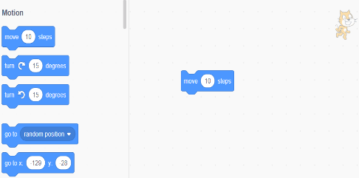  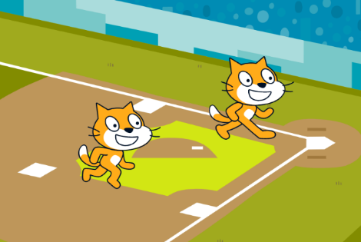  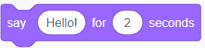
The Basics of Scratch
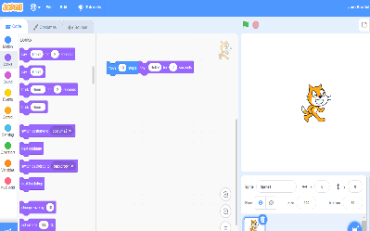
-What is Scratch? Scratch is a website/ app that lets us code our own stories, games and animations.

-Scratch helps us to learn how to use programming language, whilst also being creative and using problem-solving skills.
 |  |  | Sequencing and Algorithms | Making Music
 |  |  | -A sequence is a pattern or process in which one thing follows another.  -In Scratch, blocks can stack vertically on top of one another to create sequences.  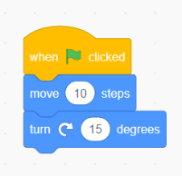  -Event blocks are used to start sequences. They are orange and have a curved shape at the top.  -Designing an algorithm (set of instructions for performing a task) will help you to program the sequence that you require. | 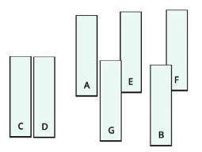  -Several sprites, each following connected sound sequences, can create music!  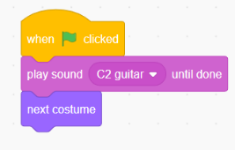  -In order to do this, you will need to carefully plan your algorithm.  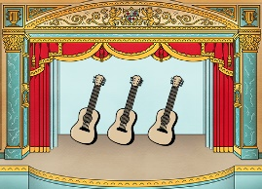  -If your animation does not work correctly the first time, remember to debug it.
There are three main areas in Scratch:  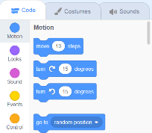  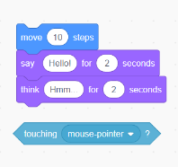  -The Blocks Palette (on the left) contain all of the different blocks: puzzle piece commands which control the animation.  -Code Area (in the middle) is where the blocks are placed to create a program.  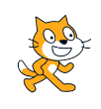  -Stage with Sprite (right) is where the output of the program is presented. The sprite is the character. | Adding/Removing Sprites: This can be done here, at the bottom of the stage. There are many sprites to choose from.  Attributes: There are three attributes of the sprite which we can change to make our animation: Code, Costumes, Sounds.  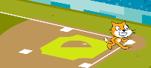  -Backdrops: Backdrops can be added by clicking on this icon (bottom right of the screen, below the stage).
Important Vocabulary

Programming Scratch Blocks Code Sprite Costume Stage Backdrop Motion Point in direction Go to Event Task Run the code Order Note Chord Bug

