COMPUTING: DATA AND INFORMATION- Branching Databases
KNOWLEDGE ORGANISER
Y3

Overview |  |  | Branching Databases
Branching Databases  -Data is raw numbers and figures. Information is what we can understand from looking at data.  -Objects can be organised into groups, based on what they are or their different attributes.  -Branching databases can help us to identify objects within sets of data. They are useful when we want to classify objects (consider objects within a certain group).  -  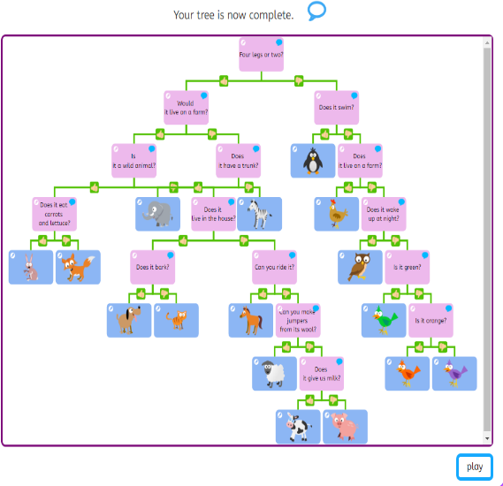 |  |  | 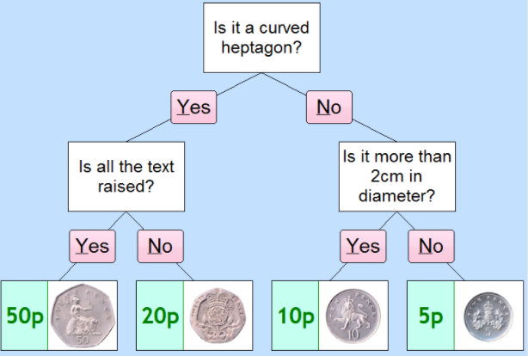  -Branching Databases: A branching database (sometimes known as a binary tree) is a way of classifying a group of objects. If it has been designed correctly, a branching database can be used to help someone identify one of the objects.  -Creating Branching Databases: Programs such as j2data can help you to create branching databases. Firstly, you need to select which objects you would like to use in your database. You can then type in ‘yes’ or ‘no’ questions to sort your objects. Add as many questions as needed until all of the objects are sorted individually. It is a good idea to have a similar number of objects in each group.  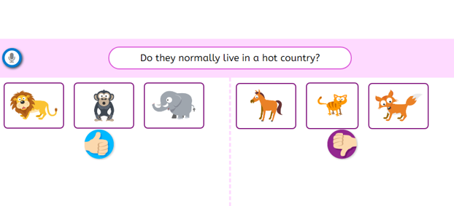
Grouping and Separating
-Grouping: Objects can be put into different groups. These groups can be made up of objects that are the same, or objects that have the same attributes (features).
Computers can help us by allowing us to put different objects into groups.
 |  |  | Structuring Branching Databases | Presenting Information
 |  |  | 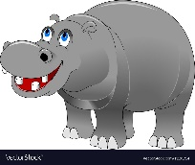  -Remember that for your branching database to be effective, the strength of the questions that you ask is hugely important. Your questions need to separate different objects based on their attributes. E.g. the question ‘does it have stripes?’ would separate the animals below. You should also carefully consider the order that you ask questions. | -Both pictograms and branching databases can be used in order to answer questions and solve problems.  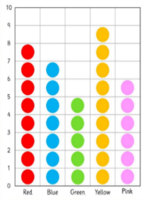  -You should know which is best to use in different situations. E.g. a pictogram is best to show the favourite colours of children in the class, whilst branching diagrams are best to identify different types of minibeasts.
-Yes or No Questions: Questions that require yes and no answers can be useful for helping us to find out the attributes of different objects. For example:  -Is it big? (size)  -Is it red? (colour)  -Is it made of plastic? (material)  -Is it heavy? (weight)  - Open Ended Questions:  An open-ended question has many different answers. For example, what is your favourite food? It is not possible to make a branching database using open-ended questions. | -Multiple Groups: Sometimes, we need to split objects into more than two groups, and so one yes or no question alone is not enough. For example, we may wish to classify animals into the different animal types (mammals, birds, reptiles, amphibians, fish, etc.). We may ask multiple yes or no questions, such as ‘does it lay eggs?’ ‘does it have hair or fur?’ etc.
Important Vocabulary
Attribute Value Questions Table Objects Branching database Equal Even Separate Structure Compare Order Organise Selecting Information Decision tree

