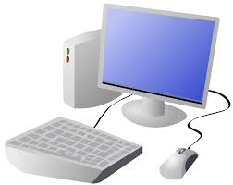
COMPUTING: CREATING MEDIA- Desktop Publishing
KNOWLEDGE ORGANISER
Y3

-The styles tool is a real time saver. You get to choose a number of different features, e.g. fonts and colours, and it will apply the rules to the whole document.
Overview |  |  | Text Tools
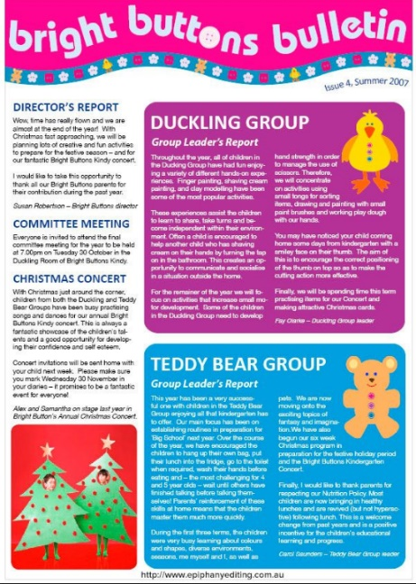  Desktop Publishing  -Desktop publishing is when we create documents using page layout software.  -We can use desktop publishing to make things like newsletters, brochures, magazines and newspapers.  - Some examples of software that we can use for desktop publishing are Microsoft Publisher, Adobe Spark and Canva.  -When using desktop publishers, we consider how images and text are laid out the page in an eye-catching and appropriate format.  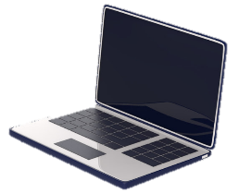 |  |  | The toolbar is the set of icons and buttons that are at the top of the page in a desktop publisher. You should already know some of these from your earlier study:
 |  |  | These tools can change the text.  The B makes the text Bold.  The I writes the text in Italics.  The U underlines the text.  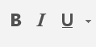 | Clicking on this icon allows you to change the size of the text. After pressing the icon, you will see a list of numbers. The larger the number selected, the bigger your text will be.  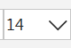  Clicking on this icon opens the text colour tool. It allows you to change the colour of the text. There are often many colours to choose from.
 |  |  | Clicking on this icon allows you to change the font (style) of the text. Most desktop publishers have many styles to choose from.  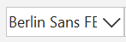 | 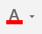
Layout of A Page |  |  | The undo tool reverses the last thing that you did. If you make a mistake, the undo tool can help you to get it back to how it was.  The redo button re-does something that you have undone!
When desktop publishing, we consider how we can lay out a page in the most interesting, eye-catching, and appropriate ways, to suit our purpose and audience.

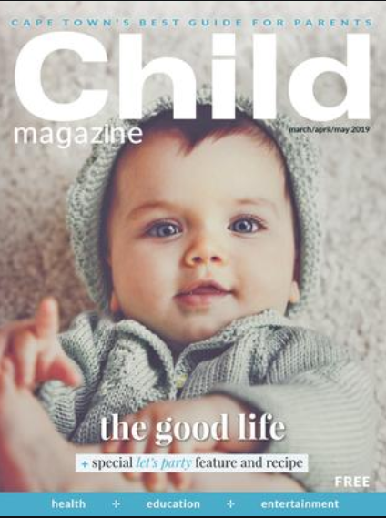  Think about how different colours make us think and feel.  The title should be large, bold and clear. It is normally the largest text on the page.  Think about where you will put the date and price of the magazine – this is important information!  Consider which font you will use – different fonts create different ideas and feelings.  What is the main story of the magazine? How can you sum the story up in a few words?  Magazines are normally in portrait orientation. Think about how you lay out text and images. |  |  | Image and Layout Tools  Templates have a pre-arranged layout, colour scheme and style that you can adapt for your needs!
 |  |  | 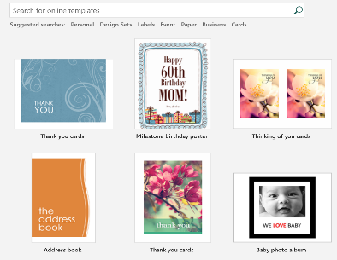 | 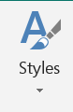
 |  |  | 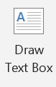  -Text boxes allow you to type text anywhere on the document. The box itself can be coloured. You can make the text box as large or small as you want, and rotate it using this symbol. | 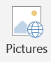  -This tool lets you insert pictures into your document. You can select pictures already on your computer, or search the internet for pictures. Pixabay contains lots of pictures that you can legally use in publications.
Important Vocabulary

Desktop publishing Text Images Font style Template Orientation Placeholder Copy Paste Layout Purpose

