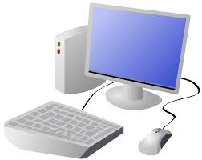
COMPUTING: PROGRAMMING- Introduction to Quizzes
KNOWLEDGE ORGANISER
Y2

Overview |  |  | Creating Quizzes
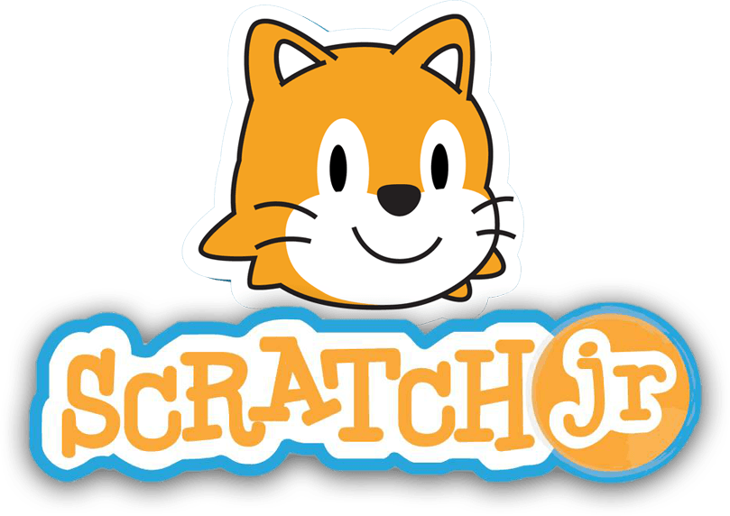  Quizzes in Scratch Jr.  - Programming is when we make a set of instructions for computers to follow.  -Scratch jr. is a program that we can use to code programs using a series of command blocks. This can be used to design quizzes.  -We use algorithms (a set of instructions to perform a task) to program the sprite to do different things.  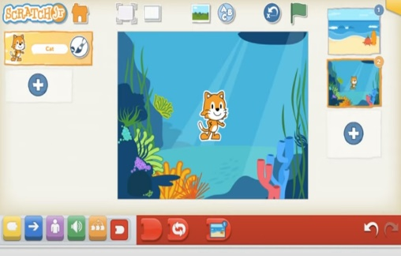 |  |  | 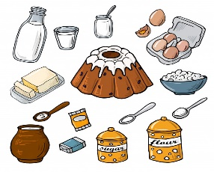  -Outcomes: An outcome is something that happens as a result of us doing something. E.g. in cookery, we can mix and cook ingredients to make an outcome of food! In Scratch Jr. a sequence of commands is followed and this results in an outcome.  -Quizzes in Scratch: We can create simple quizzes in Scratch jr. where the user can select an answer by clicking on a sprite. An outcome occurs when the sprite is clicked.  -Adding and Programming Sprites: We need multiple sprites for the user to select from. To add new sprites, we choose the + option (see right). We can program multiple sprites. The sprite we are programming is the picture in the programming area.  -Programming Sequences: Consider what question to ask your users, e.g. Who lives here? Program each sprite with a command sequence, so that they know if they are right or not when clicking on the sprite.  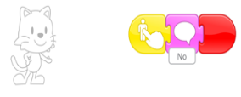  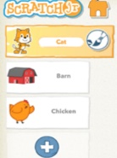  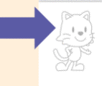
The Basics of Scratch Jr.
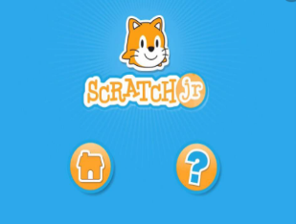
-What is Scratch Jr? Scratch is a website/ app that lets us code our own stories, games and animations.
-Sprites: Scratch Jr. uses characters called sprites. The main sprite is a cat called Scratch.
-Home: Clicking on the house takes you ‘home’ to your project screen.
 |  |  | Algorithms and Programming | Debugging
 |  |  | 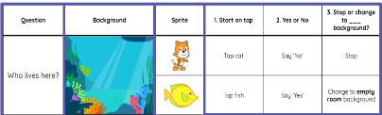  -An algorithm is a set of instructions for performing a task. Designing an algorithm can help us to make the quiz work in the way that we want it to.  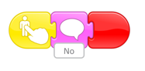  -Programming is when we move the blocks into the position (based on our algorithm design). Programming uses a code that the computer can understand. In Scratch jr. this makes our quiz animation do the things we want it to. | 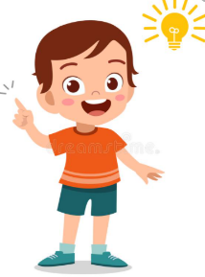  -Sometimes, things don’t work exactly how we want them to the first time. This may be a problem with our algorithm, or we could have made a mistake in our programming.  -If the animation does not work correctly the first time, remember to debug it. This means finding and fixing the problems.
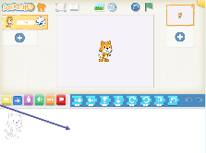  -These (right) are the programming blocks. We drag them into the programming area (right). Clicking the block in the area makes the sprite perform on the stage.  -Background: Backgrounds are added by clicking this icon (right).  -Running the Code: Run your animation by tapping the full screen icon, and then the green flag. | 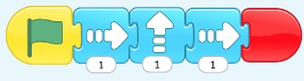  -Sequences: -A sequence is a pattern or process in which one thing follows another. In Scratch Jr. we can stack blocks together side by side in order to create sequences. We can change the number at the bottom of some blocks to alter distance or size.  -Start Blocks: Start blocks are yellow & are used to start/ run programs. The second block on the right starts the program when the sprite is clicked on.  -End Blocks: End blocks are red. These are used to end your program.
Important Vocabulary

Start Outcome Predict Blocks Actions Change Build Match Compare Evaluate

