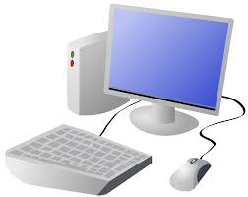
COMPUTING: DATA AND INFORMATION- Pictograms
KNOWLEDGE ORGANISER
Y2

Overview |  |  | Pictograms and Block Diagrams
Pictograms  -Data can be numbers, words or figures. Information is what we can understand from looking at data.  -Objects can be organised into groups, based on what they are or their properties (features).  -Data about different groups can be recorded and presented by using pictograms, tally charts and block charts. This data can answer questions and solve problems.  -  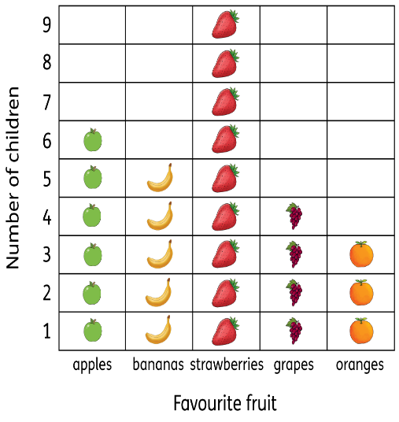 |  |  | 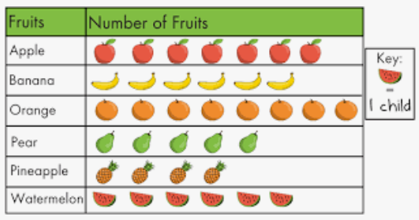  -Pictograms: A pictogram is a chart that uses pictures to display data. They can be made using pens or paper, or they can be made using a computer. The pictogram on the right shows the favourite fruits of a group of school children. Each piece of fruit shows what each child selected.  -Block Charts: Block charts work in a similar way to pictograms, except each object is presented as a block. The block diagram on the right presents how different children get into school.  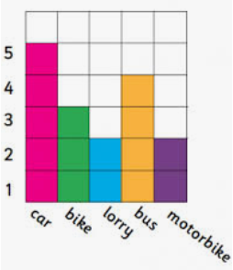
Grouping, Counting and Tallying
-Grouping: Objects can be put into different groups. These groups can be made up of objects that are the same, or objects that have the same properties (features).
Computers can help us by allowing us to put different objects into groups.
 |  |  | Presenting and Using Information | Answering Questions
 |  |  | -Computer programs such as j2data can help us to create pictograms and block charts. Clicking the + and – icons add and subtract pictures from our diagram.  -Using Data: There should be a reason to collect data, and so it should be easy to read. E.g. this data could help someone know which fruits to buy if they are hosting a party, or help the school chef know which fruit to order in. | -Pictograms can be used in order to answer questions and solve problems.  -Examples may include:  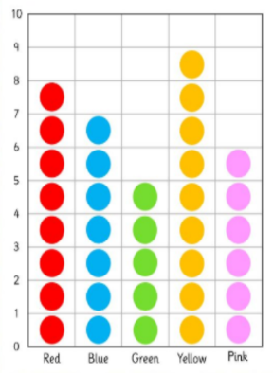  -Which colour was the most popular? Which colour was least popular?  -How many more chose yellow than chose pink?  -What is the total of red and blue combined?
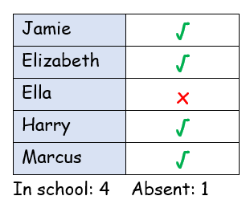  -Counting: Computers can be programmed to count the amounts in each group.  -For example, when your teacher takes the class register, the computer program can count how many ticks and crosses there are. The computer can then tell your teacher how many children are in class. | -Tallying: Tallying helps us to record as we count. We chunk into groups of five, with the first four counts looking like sticks, and the fifth count making the ‘gate.’  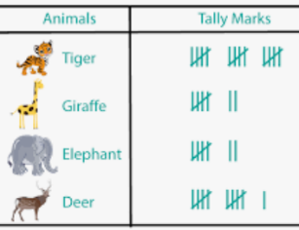  -Tally Charts: Tally charts are used to collect data about the number in each group quickly.
Important Vocabulary
Organise Tally chart Votes Total Pictogram Enter Compare Count Explain Attribute Difference Most/least popular Conclusion Block diagram

