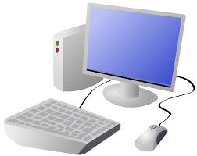
COMPUTING: SYSTEMS, NETWORKS AND ONLINE SAFETY- I.T. AROUND US.
KNOWLEDGE ORGANISER
Y2

Overview |  |  | I.T. in the Home | I.T. in the World
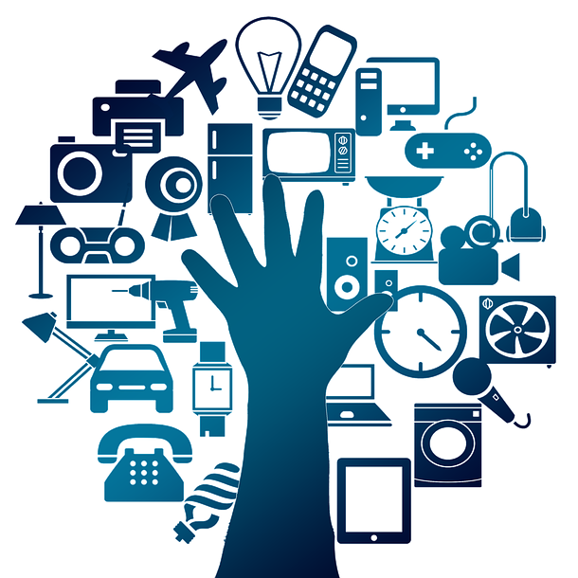  Technology Around Us  -You should already know that Technology is something that has been made by people to help us.  -Technology is ‘man-made’ and not ‘natural.’  -Information technology (I.T.) includes computers and things that work with computers.  -Information technology is in lots of important items in our homes and around the world.  -It is important that we understand how to use information technology safely. |  |  | There is lots of information technology in our homes. I.T. is used to:  -Control the tools and appliances that we use in the home, e.g. the panel for the heating, setting the washing machine, and programming the microwave.  -Help us to communicate with one another, e.g. the internet router and the telephone.  -Entertain us, e.g. the information technology in toys, consoles and computer games.  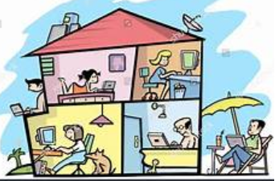 | There is also lots of information technology in the wider world  -I.T. can be found in shops, e.g. the barcode, barcode scanner and till all work together to scan your shopping items.  -I.T. can be found in ATMs, e.g. the bank card, chip and PIN card reader help you to access your bank account.  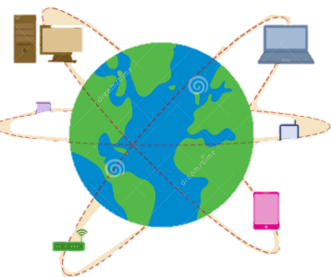  -I.T. can be found outside, e.g. traffic lights, buttons, and signals work together to tell you when to cross the road.
Information Technology
-Technology is the name for man-made things that help us.

-Information technology is made up of computers and things that work with computers.
 |  |  | How I.T. Improves Our World
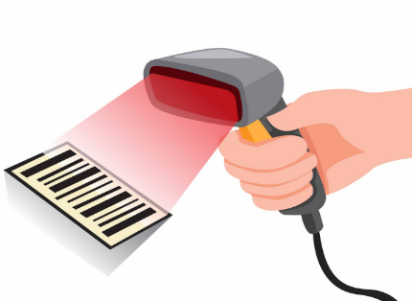
-Information Technology helps us in lots of different ways in our daily lives.
-I.T. can help to make things quicker and easier. E.g. at the supermarket, the barcodes/ scanners quickly add up the product numbers and costs of the things that we want to buy.
-I.T. can also help us to stay safe. E.g. The traffic lights, buttons and signals help us to avoid traffic when crossing the road.
-I.T. also helps us to communicate with one another and have fun! E.g. it can connect us to the internet, and can allow us to play games, share and receive information.

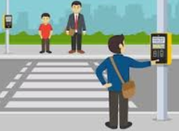

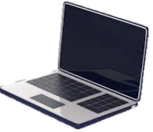  -Information technology includes computers, for example desktop computers, laptops, games consoles, smart phones and tablet. | 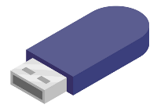  -Information technology also includes devices that work with computers, e.g. USB sticks, SMART boards and digital cameras.
Using Technology Safely
We can create and follow a number of rules to use technology safely, e.g.:
-Make sure that the games and apps that we access are age-appropriate.
-Always sit down when using devices. They can be broken if dropped!
-Do not use devices at social times, e.g. at the table. It is bad manners.
-Stick to using technology at agreed times. Too much screen time is not good for us!
- If you see something upsetting online, make sure you tell a trusted grown up.

Important Vocabulary
Information Technology Computer Barcode Scan

