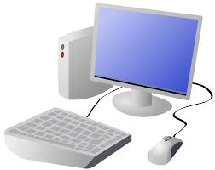
COMPUTING: CREATING MEDIA- Digital Writing
KNOWLEDGE ORGANISER
Y1

Overview |  |  | The Toolbar
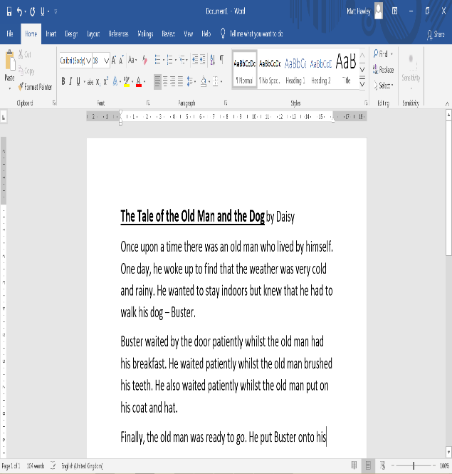  Digital Writing  -We can use digital devices to help us to write.  -The programs that we do this on are called word processors.  -When we use word processors, we can use a keyboard and a mouse to enter and remove text.  -We can also change the look of the text by changing things like the font and the size.  -Writing digitally has the benefit that it is neat and tidy, and it can be easily edited. |  |  | The toolbar is the set of icons and buttons that are at the top of the page in a word processor. Below are some of the most common tools.
 |  |  | These tools can change the text.  The B makes the text Bold.  The I writes the text in Italics.  The U underlines the text.  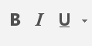 |  | Clicking on this icon allows you to change the size of the text. After pressing the icon, you will see a list of numbers. The larger the number selected, the bigger your text will be.  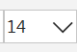
 |  |  | Clicking on this icon allows you to change the font (style) of the text. Most word processors have many styles to choose from.  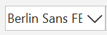 |  | Clicking on this icon opens the text colour tool. It allows you to change the colour of the text. There are often many colours to choose from.
Using a Keyboard |  |  | When we want to save our writing, we should click on this icon. The first time that we save, we need to choose a file name and a location (folder) to save it in.
-A keyboard is an input device that lets a person enter letters, numbers and symbols.
-Most keyboards are laid out in the same way. This is often called the QWERTY layout.
-The buttons on a keyboard are called keys.
-You can choose where to write by moving the cursor (the arrow) over the page. When you click a flashing line will appear. This is the text cursor. It allows you to type in letters.
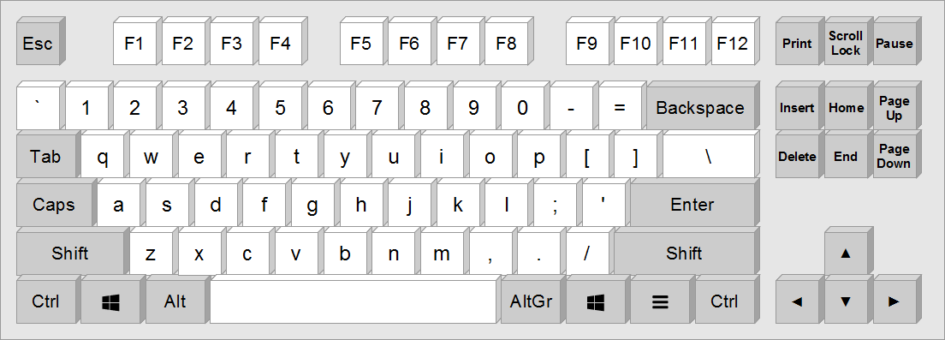

Enter key, moves everything after the text cursor down one line.
Backspace key, removes the letter on the left of the text cursor.
Caps key, press this for capital letters.
Arrow keys, can move the text cursor.
Space bar, for leaving spaces.

 |  |  | Making Careful Choices
 |  |  | The undo tool reverses the last thing that you did. If you make a mistake, the undo tool can help you to get it back to how it was.  The redo button re-does something that you have undone! | Hand writing or Digital writing?  -Hand writing is often seen as more personal. For many people, it is a bit quicker than typing.  -Digital writing is often neat, tidy and easy to read. It can be more easily edited (changed).

Important Vocabulary
Font
Word Processor
Select
Backspace
Spacebar
Underline
Toolbar
Cursor
Shift
Italic
Text
Numbers
Keys
Bold

