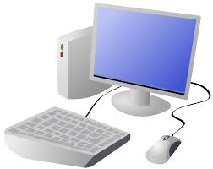
COMPUTING: CREATING MEDIA- Digital Painting
KNOWLEDGE ORGANISER
Y1

Overview |  |  |  | More Complex Tools  This is the spray-paint tool. When you hold down the left button on the mouse, it is like you are spraying a can of spray-paint. With this tool, it is more difficult to colour neatly.
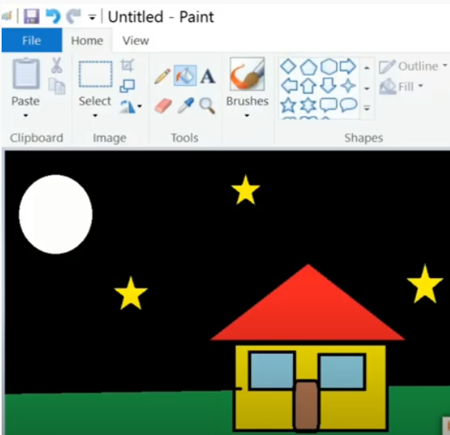  Digital Painting  -We can use digital devices to help us to draw and paint pictures.  -When we use paint programs, we can use tools to create different effects.  -We can draw in different ways, using the pencil tool, lines and shapes.  -We can also change sizes and colours. |  |  |  | This is the fill tool. It lets us fill a shape with a colour of our choice. Be careful though, if the shape has any gaps in it, the fill tool will colour everything else!
 |  |  |  | The line tools help us to draw neat lines. |  | The shape tools draw circles, rectangles, or squares. As we click and drag using the left mouse button, we make the shape bigger and smaller.
Simple Tools |  |  |  | When we want to save our painting, we should click on this icon.
-The buttons at the top/side of the page are called tools, and they all have different jobs.
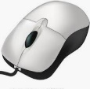
-By clicking on a tool (with the left button on our mouse) we can select to use it.
 |  |  |  | Making Careful Choices
 |  |  |  | Be clicking on this icon, we are able to choose the size of the lines that we draw with.  We can choose thick, bold lines, or thin lines. | We can add text to our painting by clicking this icon. We use the keyboard to type letters or numbers.  We can select different colours for our artwork.
This is the pencil tool. It draws freehand. As we click and hold the left mouse button, it draws on the page. As we hold and move the mouse, the pencil follows on the page! | The undo tool reverses the last thing that you did. If you make a mistake, the undo tool can help you to get your drawing back to how it was.  This is the paintbrush tool. It works freehand, like the pencil does. We can choose different colours (by clicking on them) to paint with!
The eraser tool lets us rub out parts of our drawing when we have made a mistake. It works by clicking and holding the left mouse button over the areas to erase.

Important Vocabulary
Shape tools
Line tool
Brush style
Pointillism

Primary Colours
Fill
Erase
Tool
Undo

