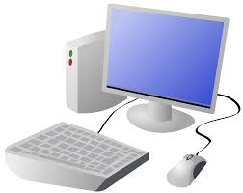
COMPUTING SYSTEMS AND NETWORKS: Technology Around Us
KNOWLEDGE ORGANISER
Y1

Overview |  |  | Computers
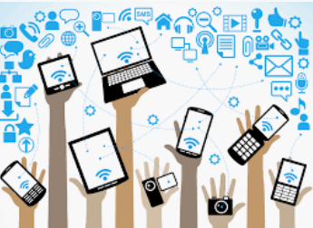  Technology Around Us  -Technology is something that has been made by people to help us.  -Technology is ‘man-made’ and not ‘natural.’ Technology is things like computers, traffic lights, laptops, and iPads.  -Computers are a type of digital technology.  -Some of the different parts of a computer are the:  monitor, mouse and keyboard.  -There are a some important rules to help us use computers safely.  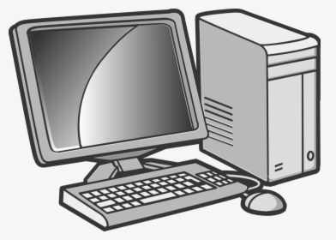 |  |  | -Desktop computers need to be put on a table or desk. Laptop computers are portable – they can be moved to different places.  -The screen (or monitor) displays what the computer is doing.  -The mouse lets you select and move objects (some computers have a trackpad instead).  -The keyboard lets you type letters and numbers.  -Computers can run different programs. Programs do different tasks on the computer. E.g. Microsoft Word, Microsoft PowerPoint and Paint.  -When we are using a program, we can save our work by clicking on this icon.  Screen/ Monitor  Base Unit  On/Off Switch  Mouse  Keyboard
Technology
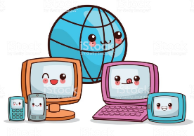
-Technology is the name for man-made things that help us.

-Technology is all around us and helps to make our lives easier.
 |  |  | Using a Mouse | Using a Keyboard
 |  |  | 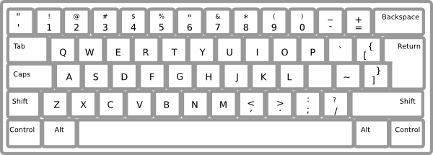  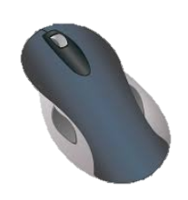  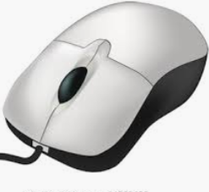  -The mouse can be used to click and drag.  -Clicking the left button lets us select something. Clicking twice quickly lets us open files and programs.  -Holding the left button down allows us to drag things. | -Writing on a computer is called typing. We do this on a keyboard.  -Holding the shift key, or pressing caps lock, helps us to type a capital letter.  -Delete and backspace buttons can help us to remove typing.
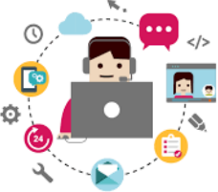  -Digital technology is the name for electronic items that create and store information, e.g. computers, mobile phones, and televisions. | 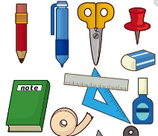  -Non-digital technology is the name for non-electronic items do not create and store information.
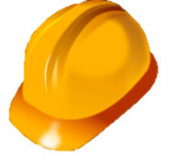
Using Technology Safely

When using technology, we should:
-Hold the device carefully and use it gently.
-Not have food and drink around the device.
-Only use the programs that we are supposed to be using.
-Take turns and stop using the device when we are being spoken to.

Important Vocabulary
Responsibly
Space bar
Safely
Keyboard
Mouse
Screen
Computer
Click
Drag
Technology

