You might be

feeling sad

right now.



Why can’t I go to school?

School

There is a nasty

germ called

Coronavirus

And it can

make you feel

really poorly

This very important man, Boris Johnson



Has decided

that we all

need to stay

at home to

Home Time

keep safe

This will help to stop people getting poorly



To help you

feel happy

at home





You can draw or paint

Art

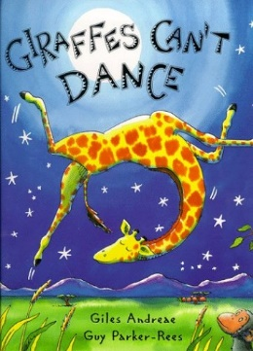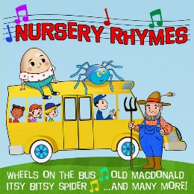

Listen to a

story



Or play with your toys

Soon the

germ will

be gone



and people

will feel

better 😊



Then we can

go back to school😊