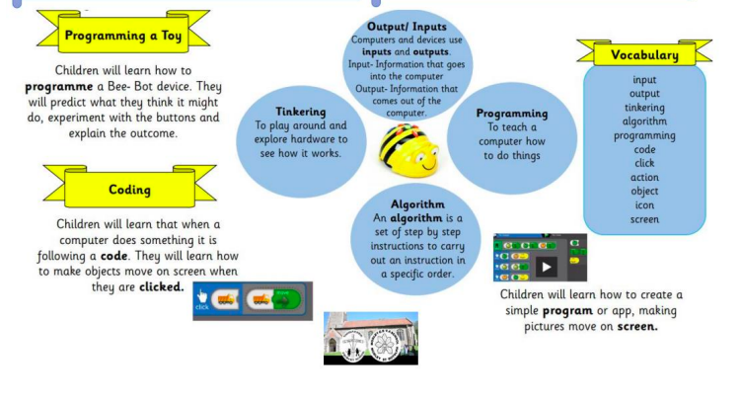
EYFS- Autumn Term Computing

