Year 6 | Autumn 1 | Enquiry Question: What is the best way for a Muslim to show commitment to God? |  |  |  |  |  |  | Religion: Islam
In this enquiry, you will look at the importance of the five pillars to most Muslims. You will learn the beliefs behind the practices and understand how Muslims show commitment each day, highlighting the importance of Allah to Muslims.
What we will learn: |  |  |  |  |  | Link to other aspects of belief |  | Personal connection
* This enquiry considers the 5 pillars which are central to Muslim life and Worship.  * The five pillars are:  The Shahadah is a statement which is repeated many times a day ‘There is one God, Allah, and Muhammad is his prophet’  Salat - prayer, 5 times a day  Zakat - Giving 2.5% annual savings to charity  Fasting – sawm. This commemorates the giving of the Quran to Muhammad by Angel Gabriel. The fast lasts a month and is during daylight hours.  Hajj – Pilgrimage to Makkah in Saudi Arabia once in a lifetime |  |  |  |  |  | - Look at the ways Zakat money is used  - International Muslim charities  - Sunni and Shia different practices  - The Qur’an – some key verses and interpretations. |  | - What 5 things are the most important in my life?  - How do I show commitment at home? At school? To my friends?  - Why is it important to put effort into important things?
Key Vocabulary |  |  |  |  |  |  | Impact on believer/daily life | 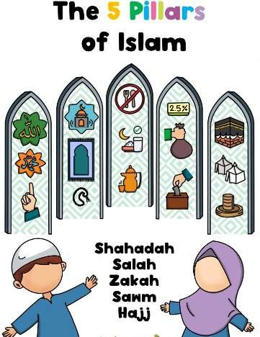
Ramadan: Month of fasting. The month the Qur’an was first revealed to Muhammad |  |  | 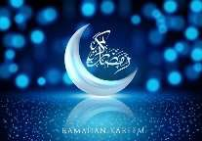 | Five Pillars: fundamental practices in Islam, considered to be obligatory acts of worship for all Muslims | 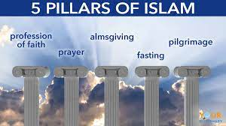 |  | - The Shahadah and Salat form a major focus of every day  - Opportunities should be taken to look after the poor and preparations for Ramadan will see communities support each other especially if the fast falls during the hotter months.
Muhammad: the final prophet of Islam |  |  | 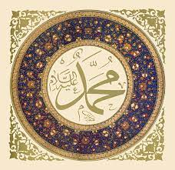 | Zakah: it is a  financial term that  obligates Msulims to  donate a portion of  their wealth to  charitable causes
Qur’an: Holy book. The word of Allah in Arabic |  |  | 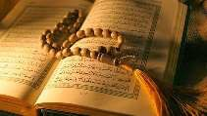 | Sawm: the Arabic term used to describe the act of fasting. Fasting during the month of Ramadan | 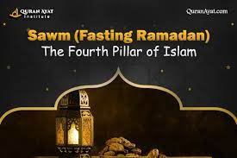
Allah: The one and only God in Islam |  |  | 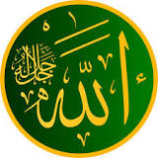 | Hajj: a sacred pilgrimage that is required of every Muslim at least once in their lifetime. Mecca in Saudi Arabia | 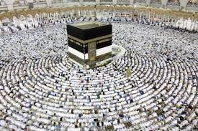
Home learning ideas/questions:
What are we committed to as a family? How can we support each other? Why is being committed to something not always easy?

