Religious Education: | Year 5 | Autumn 1 |  | Enquiry Question: What is the best way for a Hindu to show commitment to God? |  |  |  |  | Religion: Hinduism
In this enquiry, you will look at aspects of how Hindus worship. You will consider ways in which commitment is shown and the beliefs behind the symbols and actions.
What we will learn: |  |  |  |  |  | Link to other aspects of belief |  | Personal connection
- Hindus believe in Brahman as the one true God who is formless, limitless, all-inclusive, and eternal.  - Puja  - Worship can be performed alone at home or in a mandir/temple with others  - Offerings are always given to God  - Vedas  - The Vedas are the oldest of the Hindu holy books  - Veda means knowledge  - The Vedas include laws covering many aspects of life  - The four goals - (purusharthas)  - For many Hindus there are four goals in human life (purusharthas); namely  - Moksha - the release of the soul (Atman) from the cycle of rebirth.  - Dharma - the code for leading your life – including duties  - Artha – Being prosperous legally – this includes earning money through doing a job beneficial to others. Earning wealth benefits the community as well as self.  - Karma- this includes desire and a passion for life |  |  |  |  |  | - Pilgrimage to the River Ganges – another form of commitment  - Different deities and their characteristics – deities may be popular for different times and needs  - The caste system – traditional class system of human life in India – unpopular now but still present in rural India |  | - Do I have any special books?  - What are they and why are they special to me?
 |  |  |  |  |  | Impact on believer/daily life
- Worship can take many forms and is a very personal aspect of daily life. Most Hindus will worship every day mostly at home using a private shrine.
- Remembering the laws in the Vedas will help Hindus respect nature as well as focus on their personal morality.
Key Vocabulary
Puja: worship ritual performed by Hindus, Buddhists and Jains to offer devotional homage and prayer to one or more deities  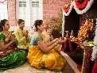 |  |  | Dharma: the doctrine (teachings), the universal truth common to all individuals at all times, proclaimed by the Buddha.  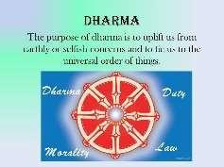 |  | Gayatri Mantra: one of the oldest and most powerful mantras / prayer. An important prayer or mantra  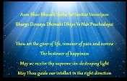 |  | Purusharthas: the four goals. The inherent values of the universe. Moksha, Artha, Kama, Dharma  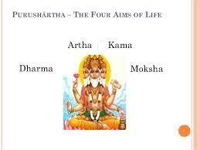
Vedas: Holy books  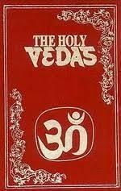 |  |  | Puja Tray: during worship, Hindus use many items, which are kept on a Puja tray. (bell, pot of water, a diva lamp, an incense burner, a pot of kum kum powder and a spoon)  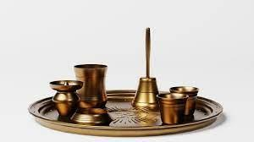 |  |  |  | Karma: Desire and passion for life  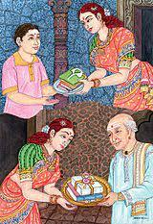
Home learning ideas/questions: If we have ever been to an event at or visited a place of worship (a church or building from another religion) what did we feel about it? Do we have special places we go as a family/household because they have special significance to us? What are they and why are they special?

