Religious Education: | Year 4 |  | Autumn 1 | Enquiry Question: Is it possible for everyone to be happy? |  |  |  | Religion: Buddhism
In this inquiry, you will talk about the story of the Buddha. You will consider the choices he made and the outcomes of his actions and reflect on these from a Buddhist’s point of view as well as your own.
What we will learn: |  |  |  |  | Link to other aspects of belief |  | Personal connection
- The Story of the Buddha follows a rich but unfulfilled Prince through a journey of self- discovery leading to teachings that explain the meaning of life and our part in the world.  - Key Stories and teachings include * The Story of the Buddha (provided) leading to his teachings which include * The Three marks of existence/ universal truths * The Four Noble Truths  * The Noble Eightfold Path * The Five Precepts |  |  |  |  | - Pilgrimage to Lumbini (birthplace) and Bodh Gaya (place of enlightenment)  - Buddhist temple visit  - The importance of Meditation – use of Mandalas |  | - What does the story of the Buddha tell me?  - Why wasn’t the rich prince happy?  - What sort of things can’t be bought?  - Who is precious to you?  - What do you think is the meaning of life?
Key Vocabulary |  |  |  |  |  | Impact on believer/daily life | 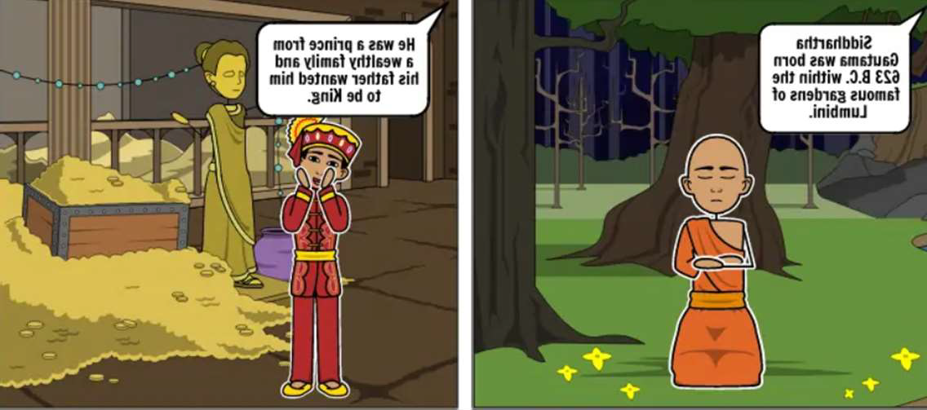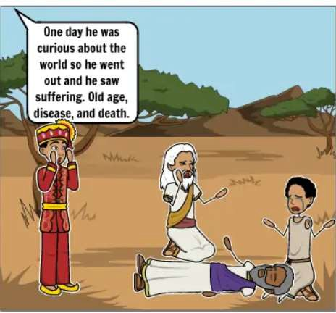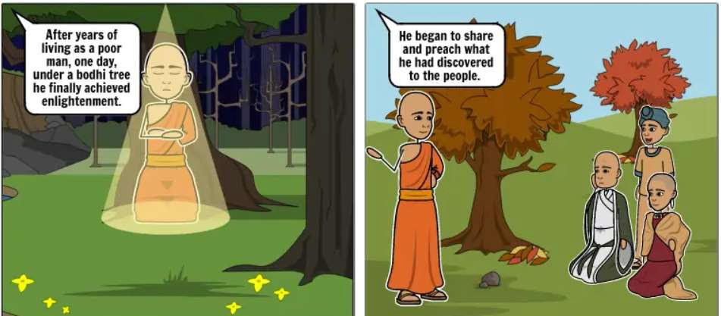
Siddhattha Gautama: A Prince who would become known as the Buddha  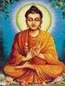 |  | Bodhi: the final  enlightenment,  leads to Nirvana |  | 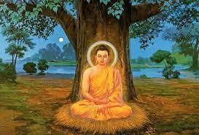 |  | - Understanding the key teachings of the Buddha helps Buddhists approach life via the middle way.  - Attachment to things leads to suffering so Buddhists try not to be materialistic.  - Buddhist teachings focus on living the right way, harming no living thing and being mindful of others and circumstances around you
Buddha: an enlightened one  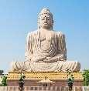 |  | 8 fold Path: the 8 elements of the path |  | 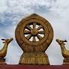
Enlightenment:  understanding the true  nature of existence  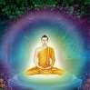 |  | Prince Siddhattha:  Referred to as the Buddha ‘the awakened’. |  | 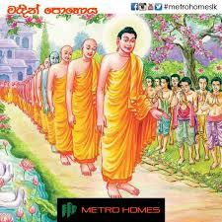
Meditation: calming one minds and body |  | Gautama Yasodhara: the wife  of Prince Siddhatth |  | 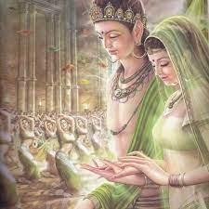
Home learning ideas/questions:
How can we take steps to be happier? What is the purpose of our lives? How could being rich cause problems?

